International Journal of Computer Information Systems and Industrial Management Applications
ISSN 2150-7988 Volume 18(16s) 2026 pp. 1127-1140
https://doi.org/10.70917/ijcisim-2026-xxxx
Article
A Comprehensive Review of The Circular Economy Model for Solid Waste Management in Malaysia
Nurul Farhaini Razali^{1*}, Yusri Arshad², Fam Soo Fen³, Norhafizah Mohamad Dasuki⁴, Syakirah Ahmad⁵, Azman Mohamad⁶
^{1*,2,3} Fakulti Pengurusan Teknologi dan Teknousahawanan, Universiti Teknikal Malaysia Melaka, Melaka, Malaysia
⁴ Sekolah Asasi Teknikal dan Pengajian Diploma, Universiti Teknikal Malaysia Melaka, Melaka, Malaysia
⁵ Jabatan Keusahawanan, Fakulti Keusahawanan dan Perniagaan, Universiti Malaysia Kelantan, Kelantan, Malaysia
⁶ Pengurusan Sisa Pepejal Mubaarakan Sdn. Bhd., Kelantan, Malaysia
^{1*}farhaini@utem.edu.my; 2ayusri@utem.edu.my; 3famsoofen@utem.edu.my; 4norhafizahdasuki@utem.edu.my; ⁵syakirah.a@umk.edu.my; 6azman.pspm@gmail.com
^{1*} https://orcid.org/0000-0002-3687-5154; 2 https://orcid.org/0000-0002-0473-033X; 3 https://orcid.org/0000-0001-9439-6074;
⁴ https://orcid.org/0000-0003-4665-4168, 5https://orcid.org/0009-0006-4134-547X,
⁶https://orcid.org/0009-0006-3061-4005
*Corresponding Author: farhaini@utem.edu.my
Abstract: The Circular Economy concept has been accepted worldwide, including in Malaysia. This concept is a shift from a linear economy, which is a take-and-dispose system, to a system that focuses on waste prevention, resource recovery, recycling, valorisation of organic waste, energy recovery, and active stakeholder engagement. The Malaysian Government has introduced the Blueprint for Solid Waste Circular Economy 2025-2035, the National Cleanliness Policy 2030, source-separation programmes, and plastic sustainability initiatives to support the transition to the Circular Economy. However, the implementation of these practices remains fragmented at the institutional and operational levels. Hence, this paper aims to create awareness among all concerned stakeholders by proposing an integrated Circular Economy Model for Solid Waste Management in Malaysia. The suggested model, drawing on the literature on global and Malaysian initiatives, comprises source separation, food waste prevention, material recovery, plastic circularity, digital waste monitoring, stakeholder governance, market creation, waste-to-energy, and performance measurement. The paper contributes a comprehensive framework that merges Circular Economy principles with energy efficiency. It aims to guide policymakers, local governments, industry stakeholders, and academics in promoting solid waste sustainability in Malaysia.
Keywords: Circular Economy, Linear Economy, Solid Waste Management, Sustainability, Waste-to-Energy

- Introduction
Due to rapid urbanisation, high population growth, industrialisation, and changes in consumption patterns, developing and emerging countries have placed greater emphasis on sustainability in solid waste management (Osime, 2026; Mthembu et al., 2026). The circular economy has been introduced to overcome issues such as resource depletion, landfill dependencies, greenhouse gas emissions, and the loss of valuable materials from the economic system. The conventional linear waste management paradigm is based on the concept of ‘take, make, consume and dispose’ that has been criticized as it is not effective in addressing the issues (Mthembu et al., 2026; Praveenkumar, 2026; Rotimi et al., 2025).
To solve waste problems, the concept of a closed-loop system in the circular economy was established to prevent waste, make efficient use of resources, and recover, reuse, and recycle materials (Granados & Adelekan, 2026; Sudeep & Sunil, 2026; Srivastava et al., 2026; Li, 2026). The concept strives to create awareness among interested parties that the end destination of waste is not the landfill, but it may be repurposed and contribute to economic sustainability.
Instead of the traditional linear economy, a more efficient resource recovery is proposed (Lajara, 2026; Muhammad et al., 2026; Kawsar et al., 2026). Some examples of such recovery are reclamation, recycling, composting, energy conversion, and reintegration into production and consumption processes (Nguyen Thi Thuy, 2026; Dzreke & Dzreke, 2026). Normally, people did not correctly separate and reuse organic trash, plastics, paper, metals, glass, textiles, and many other recyclable materials (Mthembu et al., 2026). Proper management and treatment of these waste streams will enhance material circularity, increase renewable energy production, decrease strain on landfills, and improve environmental performance (Osime, 2026).
To enhance the present linear strategy in solid waste management, Malaysia has launched the Blueprint Ekonomi Kitaran bagi Sisa Pepejal di Malaysia 2025–2035 (Kementerian Perumahan dan Kerajaan Tempatan, 2024). The Blueprint supports participation and efficiency, waste generation reduction, improvement in stakeholder participation, and supports the wider objectives of Malaysia’s low-carbon and net-zero emissions. This policy direction is in line with the country’s overall sustainability plan, which includes the National Energy Transition Roadmap, and stresses the importance of energy efficiency, renewable energy, and low-carbon growth (Ministry of Economy Malaysia, 2023).
Some mechanisms related to the Circular Economy have been introduced or promoted previously in Malaysia concerning solid waste management (Kementerian Perumahan dan Kerajaan Tempatan, 2024). Examples of these mechanisms include source separation, recycling programmes, material recovery facilities, food waste treatment, anaerobic digestion, waste-to-energy projects, extended producer responsibility, waste-to-money programmes, plastic circularity, public awareness campaigns and community-focused recycling programmes (Mohd Ali Murad, 2021). Besides, the Dasar Kebersihan Negara 2030 also encourages the shift from a linear to circular economy via the enhancement of 3R practices, waste separation initiatives, industry participation, waste-to-money programs and extended producer responsibility (Kementerian Perumahan dan Kerajaan Tempatan, 2019). These programs show that Malaysia has a solid waste management framework with Circular Economy principles (Kementerian Perumahan dan Kerajaan Tempatan, 2024).
Source separation is crucial for the effective implementation of Circular Economy (Asian Development Bank, 2020; Ministry of Housing and Local Government & Japan International Cooperation Agency, 2006a). When separation is done incorrectly at the source, recyclables can be contaminated, the processing of organic waste can be hindered, and the expense of managing residual garbage can increase (Ministry of Housing and Local Government & Japan International Cooperation Agency, 2006a). Malaysia’s source separation guidelines emphasise the necessity of separating solid waste at the source of generation to improve the recovery of recyclables, reduce the volume of waste sent to disposal sites, extend the lifespan of disposal sites, and reduce hazards to the environment and public health (Ministry of Housing and Local Government & Japan International Cooperation Agency, 2006b). Hence, household engagement, community education, coordination of local government, and an efficient collection system are crucial in fostering circular solid waste management (Ministry of Housing and Local Government & Japan International Cooperation Agency, 2006a; Osime, 2026).
Food waste management is one of the important parts of the Circular Economy framework (Ministry of Housing and Local Government & Japan International Cooperation Agency, 2006b; Boston Consulting Group, 2018; Economist Intelligence Unit, 2018). The waste of food and the loss of essential resources such as land, water, labour, transport, energy and industrial inputs are increasingly recognised as a major environmental and economic problem (Boston Consulting Group, 2018).
According to the Ministry of Housing and Local Government (2024), organic and food waste is the biggest portion in the landfill in Malaysia. This has become the main agenda to properly manage organic and food waste by increasing awareness that separation must start from the household, and it can contribute to energy efficiency, which is an important strategy for prevention, measurement, composting, anaerobic digestion, and biogas production of food waste.
As Al-Waked et al. (2026) stated, waste-to-energy and anaerobic digestion are the basis of garbage-to-energy efficiency. However, energy recovery is not a priority in the Circular Economy framework (Asian Development Bank, 2020). Waste avoidance, reduction, reuse, repair, recycling, and organic recovery will be followed by energy recovery of the residual waste (Kementerian Perumahan dan Kerajaan Tempatan, 2024). Therefore, a hierarchical approach should be developed to avoid any impact on the recycling and material recovery processes (Asian Development Bank, 2020). Waste-to-energy, refuse-derived fuel, landfill gas recovery, and anaerobic digestion of non-recyclable and residual waste can reduce greenhouse gas emissions, generate renewable energy, and divert waste from landfills with the right technology and environmental safeguards (Asian Development Bank, 2020).
The implementation of a Circular Economy in Malaysia’s solid waste management system is still evolving, though there are improvements in policy and operational measures (Kementerian Perumahan dan Kerajaan Tempatan, 2024; Osime, 2026). There are many agencies, waste streams, locations and stakeholder groups involved in the current projects (Ministry of Housing and Local Government & Japan International Cooperation Agency, 2006a; Watanabe et al., 2026). Therefore, a more comprehensive conceptual framework linking waste characterisation, source separation, material recovery, organic waste valorisation, plastic circularity, waste-to-energy processes, governance, digital monitoring, market development and energy efficiency outcomes (Kementerian Perumahan dan Kerajaan Tempatan, 2024) is urgently needed. Therefore, it is essential to have a framework in place to facilitate Malaysia’s transition to a more sustainable, circular and energy-efficient solid waste management system (Ministry of Economy Malaysia, 2023).
Thus, this conceptual study aims to suggest an integrated Circular Economy model for Malaysian solid waste management. The proposed model was developed based on the synthesis of international, regional, and Malaysian literature on circular economy, waste management, food waste, source separation, waste-to-energy, stakeholder governance, and energy efficiency. The paper adds to the literature by combining the views of energy efficiency and circular economy into one conceptual model pertinent to the policy direction and aspirations of the National Energy Transition Roadmap of Malaysia (Kementerian Perumahan dan Kerajaan Tempatan, 2024; Ministry of Economy Malaysia, 2023).
The paper is divided into a few sections. The first section is an introduction that gives some background information and describes the importance of research. The introduction is followed by the statement of the problem. The following is a literature review that critically appraises the existing theories and studies on the subject and identifies gaps that the study tries to fill. The conceptual approach and the framework are described in the next section. The study then proposes the circular economy model for Malaysia, its components and possible benefits. Finally, the implications of the proposed paradigm are critically discussed. The conclusion of the paper summarizes the main results and importance of the transition to a circular economy in Malaysia for sustainable development.
- Problem Statement
In 2021, Malaysia generated an estimated 38,427 metric tonnes of solid waste per day, or 1.17 kg per person per day, of which 82.5% was disposed of in landfills (Malaysian Investment Development Authority, 2021). The garbage cannot be eliminated by incineration. Even if you burn up all the garbage, you get about 10 % ash. And the final dump sites are certainly needed even if the ash is turned into harmless products that can be used for other purposes. Recycling is one of the efficient strategies to reduce the quantity of solid waste to extend the life of the ultimate landfill site and to solve the problem of land scarcity for that purpose (Kementerian Perumahan dan Kerajaan Tempatan, 2024).
Another problem is the lack of integration of waste management and energy efficiency. Energy is needed for several solid waste management activities such as waste collection, transportation, sorting, processing, treatment and disposal. Energy recovery options for some waste streams such as organic and residual waste include anaerobic digestion, biogas production, landfill gas recovery, refuse-derived fuel and waste-to-energy systems. In Malaysia, organic waste contributes 44% of the municipal solid waste generation; thus, there is great potential for biogas and renewable energy generation (United Nations Environment Programme, 2017). However, Malaysia is still in the nascent stages of its waste-to-energy capacity with only a few facilities currently in operation and a minor contribution to the nation’s energy mix (Asian Development Bank, 2020). In the absence of a sound Circular Economy framework, energy recovery could be perceived as a technical solution rather than part of a wider waste hierarchy.
Next is the engagement of stakeholders in the implementation of the Circular Economy. For circular solid waste management to be effective, households, local governments, trash concessionaires, recycling companies, producers, industries, informal recyclers, communities, non-governmental organisations and legislators must be involved. According to the Ministry of Housing and Local Government Malaysia & Japan International Cooperation Agency, 2006a, local authorities are considered the main agencies responsible for initiating, arranging, supervising and reporting on source separation initiatives. However, stakeholders’ roles are scattered throughout many programs and policy documents. Earlier studies indicated that public participation in recycling and source separation is very diverse by area and is often below 50% in certain municipalities (Ministry of Housing and Local Government Malaysia, 2024). The lack of strong coordination can lead to poor participation, lack of enforcement, limited data sharing, underdeveloped recycling markets, and diminished long-term sustainability of circular economy initiatives.
Another problem is the absence of a common framework for performance assessment. Some of the indicators that should be used to measure the circular economy beyond recycling rates include waste diversion, material recovery, food waste reduction, energy generation, greenhouse gas reductions, landfill minimisation, stakeholder engagement, infrastructure readiness, market development and policy effectiveness. Even though Malaysia has introduced the Circular Economy Blueprint for Solid Waste Management, those policy proposals still need to be fleshed out into a conceptual framework to guide further empirical investigation and practical implementation (Kementerian Perumahan dan Kerajaan Tempatan, 2024). Malaysia’s waste sector is responsible for more than 12% of the country’s methane emissions, the majority of which arise from the landfilling of organic waste (United Nations Environment Programme, 2017).
This paper contextualises the Malaysian situation and tackles the major problem of no integrative Circular Economy model that connects energy efficiency and solid waste management. Recent research and policy documents cover issues such as source separation, recycling, plastic circularity, food waste, waste-to-energy, governance and sustainability. But these factors are often treated in isolation. This conceptual paper proposes an integrated Circular Economy model for solid waste management in Malaysia that integrates waste characterisation, source separation, material recovery, valorisation of organic waste, plastic circularity, residual waste-to-energy, stakeholder governance, digital monitoring, and energy efficiency outcomes. This model is proposed to support Malaysia’s transition into a more circular, resource-efficient and low-carbon solid waste management system in alignment with the National Energy Transition Roadmap and national sustainability objectives.
- Literature Review
- Solid Waste Management
Solid waste management is the organised control of waste generation, storage, collection, transfer and transport, processing, treatment and final disposal. It covers a broad spectrum of measures to improve resource efficiency and to reduce the negative impacts of waste on the environment, society and economy. Traditionally, solid waste management systems have been linear: collect, use and dispose of it (often in landfills or via incineration) with little beneficial resource recovery (United Nations Environment Programme, 2017).
The rapid expansion of metropolitan areas, the rise of populations, industrial activity, and changing consumption patterns have led to a dramatic increase in the amount and complexity of trash being produced around the world. The rise has led to environmental problems, including more landfills, greenhouse gases, pollution of soil and water, and contamination of the oceans. For this reason, the circular economy concept has been proposed to reduce dependency on landfills and maximize resource recovery that can help to protect the environment as well as generate renewable energy (Asian Development Bank, 2020).
The new paradigm of solid waste management must begin from households and communities, as they are directly the first line that is responsible for segregating the waste. It is followed by collection and transportation systems, recycling, composting, energy recovery, and environmentally sound disposal methods. Such systems require effective institutional frameworks, technology arrangements, financial strategies, and stakeholder collaboration. This new system must be controlled by the Governments who are responsible for setting up policies and implementing rules and regulations (United Nations Environment Programme, 2017; Asian Development Bank, 2020).
Furthermore, waste management has been shaped by sustainability principles such as circularity, resource efficiency and life cycle theory. To reduce environmental impact at all stages of a material’s life cycle—from production through to disposal—they say it should be considered. Consequently, solid waste management is increasingly recognised not only as a sanitation service but also as an integral part of environmental governance and sustainable development.
- Solid Waste Management in Malaysia
Malaysia’s solid waste management system has undergone remarkable changes over the last 20 years due to the increased production of garbage, urbanisation and environmental concerns. In the past, Malaysia was very dependent on landfills for collecting and disposing of garbage. Many of these landfills were open dumps with fewer environmental controls, resulting in leachate poisoning, methane emissions and soil degradation (Ministry of Housing and Local Government Malaysia, 2006b).
Organic waste, especially food waste, constitutes the bulk of Malaysia’s municipal solid waste, accounting for over 50% of total waste generation. Plastics, paper, glass, metals, textiles and leftover garbage are the other components. The huge amount of organic content is both a problem and a possible advantage. While it generates methane emissions when landfilled, it also presents opportunities for anaerobic digestion, composting and bioenergy production (United Nations Environment Programme, 2017).
Many programs, including waste-to-energy, recycling, buyback, material recovery facilities and source separation, are still in the early stages of implementation. There is no overall plan into which many of the different initiatives fit. Despite the Blueprint launched by Malaysia, the proposed framework is still lacking elements of coherence that require a more cohesive and comprehensive structure. (Ministry of Housing and Local Government, 2024; Osime, 2026).
- Circular Economy Principle in Solid Waste Management
The circular economy is suggested as a way of improving the current linear waste idea, which is more efficient and promotes sustainable economic development through the promotion of reuse of materials and reduction of waste output. The Circular Economy is founded on the idea of systems with closed loops where materials are reused, mended, refurbished, recycled, and regenerated (Asian Development Bank, 2020). Unlike the “take-make-dispose” linear model paradigm.
The Circular Economy concept is about to change people’s perceptions that garbage can be transformed into recoverable materials and create electricity. It can minimise dependencies on new resources indirectly and safeguard the environment. Key measures include waste control, durability and recyclability, the optimal use of resources, and the creation of markets for secondary materials (Asian Development Bank, 2020).
A Circular Economy can be successfully implemented along the whole value chain, from production to consumption and waste treatment. It’s also about working together with all the many parties involved, such as governments, industry, consumers and waste management operators. This transformation depends on policy instruments such as rules, incentives and standards.
- Circular Economy Theories and Models
Waste-to-energy (WtE) is often perceived as a costly option for waste disposal and power generation, compared to other fossil fuel-fired generation alternatives. The environmental and social benefits of WtE are not as appreciated compared to other more familiar renewable energy sources such as solar and wind. WtE business models are more complicated than those of well-established alternatives in general. In WtE development, attention should be given to factors such as feedstock availability and consistent supply, technology selection, suitable policy framework, etc. Thought leadership on human civilisation provides a framework for thinking about alternative solutions to waste-related issues such as the circular economy. The circular economy shines a light on new models of corporation, investment priorities, legislation and community practices that support global civilization through less resource-intensive, efficient and polluting activities. These ideas can be simplified to explain the differences between the recycling economy, the circular economy and the linear economy (Asian Development Bank, 2020).
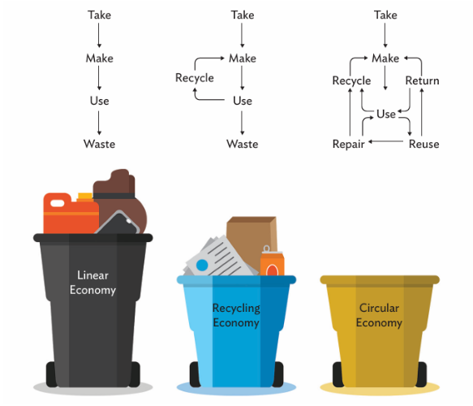
Fig. 1 The circular economy simplified (Asian Development Bank, 2020)
The second theory suggests that individuals affected by and involved with an organization feel social inclusion when the Circular Economy (CE) practices of the organization combine empowering mechanisms such as opportunity frameworks and agency-building activities (Granados & Adelekan, 2026). When social inclusion is fed back into the organization to improve and accelerate organisational CE practices, a recursive engine of inclusive circularity is thereby produced. In this scenario, SEs put inclusion and empowerment at the core of recycling, reduction and rethinking strategies. Theoretical and practical contributions to the construction of a SICE framework were also made, providing crucial insights into how circularity might work in environments of informality and exclusion. Based on these discoveries, the SICE framework has been established (see Figure 2), in which social inclusion is considered the major outcome of CE approaches rather than a side-effect. This approach underscores the way SEs integrate empowering attributes into CE practices, including opportunity structures (access to resources, formal recognition, and institutional backing) and agency-building activities (aspirations, autonomy, and collective action development). The Research reveals that circular activities such as recycling, reducing, and rethinking improve social integration of actors in the organization, such as waste pickers, by allowing people to identify themselves as social, economic, and environmental agents.
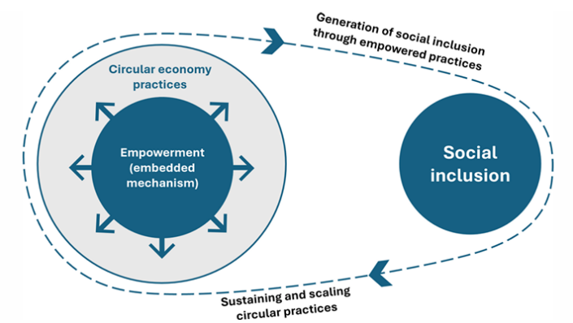
Fig. 2 Socially inclusive circular economy (SICE) framework (Granados & Adelekan, 2026)
The design of the dual-layer system is shown in Figure 3. The first layer shows how linear material flows are intercepted and redirected into a circular decision space organised according to the 10R hierarchy. Second Layer: Central Life Cycle Assessment module filtering each route. Arrows show that only pathways with net-positive results are allowed to recirculate into production cycles. This creates an iterative optimisation process that sequentially tightens material metabolism.
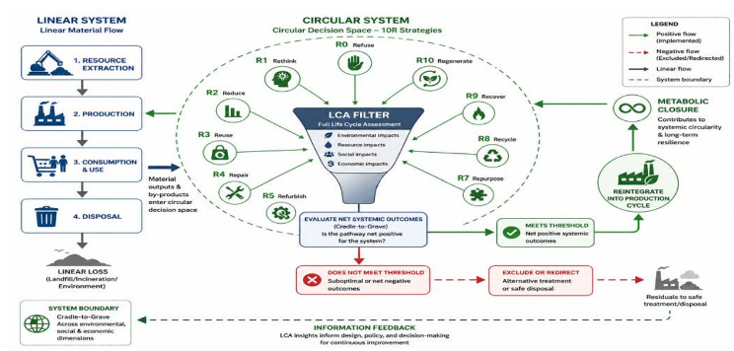
Fig. 3 The Integrated 10R-LCA Framework for Metabolic Closure (Dzreke & Dzreke, 2026)
Innovative business concepts in the circular economy (CE) such as industrial symbiosis (IS) encourage collaboration on resource sharing by using waste streams, surplus heat, water, or industrial by-products from one facility as energy inputs or raw materials for another industrial activity. Unlike traditional linear production systems, IS generates interconnected industrial networks that improve economic competitiveness by sharing infrastructure and reducing operational costs, resource efficiency, waste disposal, and virgin materials. Regionally integrated CE models can also contribute to climate change mitigation through lower lifecycle GHG emissions and low-carbon industrial production systems. Increasingly, social innovations in waste management are also being identified. Community-based recycling programs, formalisation of the informal sector, engagement of social communities as major stakeholders and CE awareness efforts make sustainability projects equitable, inclusive and robust. Figure 4 | Current technological and social developments in the area of circular waste management.
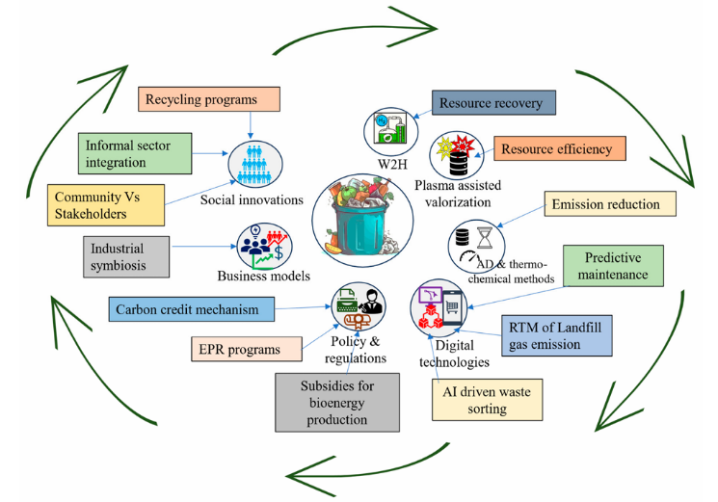
Fig. 4 Recent technological and social innovations in circular waste management (Srivastava et al., 2026)
- Circular Economy Model in Malaysia
The circular economy concepts are now being integrated into the waste management plans and regulations by the Malaysian authorities. The Circular Economy Blueprint for Solid Waste details the nation’s approach to transitioning to a more sustainable and resource-efficient system. The paradigm comprises source separation, recycling, organic waste treatment, extended producer responsibility and waste-to-energy projects (Kementerian Perumahan dan Kerajaan Tempatan, 2024).
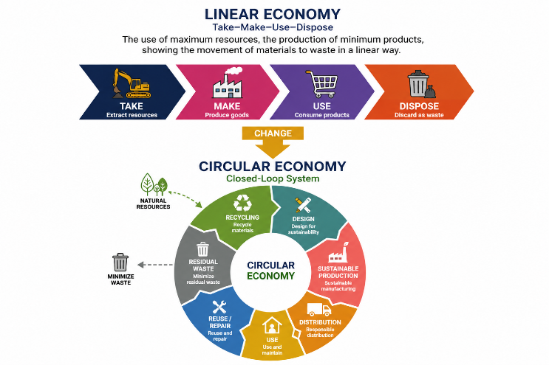
Fig. 5 Linear and Circular Economy Concept (Kementerian Perumahan dan Kerajaan Tempatan, 2024)
The challenges in implementation in Malaysia are standardisation across different areas and sectors. Furthermore, Malaysia is still not ready in terms of infrastructure; poor public awareness, inadequate enforcement, and restricted market demand for recycled materials is limited. Moreover, the failure to coordinate among relevant parties has been a cause of failure in implementing the CE.
To overcome all the problems, Malaysia needs to improve the current framework, improve the infrastructure, actively promote awareness among people, and create a platform or market for secondary materials. The system integration of different waste management components plays a pivotal role in optimising resource recovery and reducing the environmental impacts.
- Comparison of Circular Economy Model from Literature with Malaysia
The models of Circular Economy in solid waste management studied show that Circular Economy is a wider system concerning waste prevention, resource recovery, social inclusion, technology adoption, life-cycle evaluation and policy integration, and not only recycling. The circular economy is defined by the Asian Development Bank (2020) as the transition from a linear ‘take-make-use-waste’ model to one where products are recycled, repurposed, repaired and reintroduced into the economy. This model can be used to explain the basic differences between linear, recycling and circular systems. But it is not a complete account of the institutional, technological and social conditions of possibility of execution. It is rather a general conceptual map.
Granados and Adelekan (2026) add to the circular economy debate by introducing the Socially Inclusive Circular Economy paradigm. Their model shows how Circular Economy practices (recycling, reducing and rethinking) can generate social inclusion, if they are followed by agency-building activities and opportunity frameworks, as well as empowerment mechanisms. This is especially the case in solid waste management, where refuse pickers, informal recyclers, communities and social entrepreneurs often play important roles in the recovery of materials. Malaysia’s Circular Economy policy orientation does recognise the importance of stakeholder participation, unlike this paradigm, yet the national solid waste management system can improve its community empowerment and the inclusion of informal actors.
The Integrated 10R-LCA framework of Dzreke & Dzreke (2026) provides a more critical view of Circular Economy. The model suggests that circular strategies should not be applied indiscriminately. Still, each circular pathway should be evaluated using life-cycle assessment to determine whether it yields net benefits to the environment, economy, and society. This framework can be beneficial to Malaysia as it encourages some techniques of the Circular Economy such as source separation, recycling, organic waste treatment, extended producer responsibility, and waste-to-energy. Yet some efforts are circular but not necessarily the most sustainable results without thorough assessment. Therefore, life cycle thinking and performance evaluation need to be integrated into the implementation process of Malaysia’s Circular Economy model.
Srivastava et al. (2026) proposed integration of Circular Economy and social innovations, including the informal sector, community stakeholders, EPR programs, recycling programs and business models. They also suggested the integration of the model with technological features such as artificial intelligence, predictive maintenance, resource recovery, plasma-assisted valorisation and digital technologies. This strategy is of particular importance to Malaysia as the management of solid waste is evolving towards data-driven monitoring, digital platforms, intelligent sorting, technology-enabled collection and greater social engagement. Instead, this paradigm is one of the main pillars of the current direction of the Circular Economy in Malaysia, namely, digitalisation and technology. But we need to integrate more between technology, community engagement, waste recovery and energy efficiency.
The Circular Economy Blueprint for Solid Waste in Malaysia provides an adapted model for the country considering the national policy priorities. The linear “take-make-use-dispose” model is replaced by a closed-loop Circular Economy system that includes sustainable production, sustainable distribution, sustainable use, reuse and repair, recycling and material recovery, and resource recovery (Ministry of Housing and Local Government, 2024). Malaysia’s model is strong because it is in line with the needs of local implementation, national policy, and solid waste management transformation. But still, there are some gaps in comparison with global models. Some of these include strengthening social inclusion, engaging the informal sector, adopting life-cycle assessment, enhancing digital monitoring, establishing circular marketplaces, and strategically positioning waste-to-energy within the waste hierarchy.
Overall, the comparison reveals that Malaysia already has a good solid waste management policy framework for the Circular Economy, but that the implementation may be improved by incorporating important components from the international models. Hence, the proposed model in this paper consists of social inclusion, 10R-LCA assessment, technical innovation, energy efficiency, stakeholder governance, and Malaysia’s policy-based Circular Economy agenda. A more integrated approach is required to move Malaysia from uncoordinated efforts towards a more structured, quantifiable, and energy-efficient Circular Economy model for solid waste management.
From the comparison, the Malaysian Circular Economy model should not be based on a single model. Instead, it should include the policy direction of the Malaysia Circular Economy Blueprint, the waste hierarchy and energy recovery logic of the Asian Development Bank (2020), the social inclusion perspective of Granados and Adelekan (2026), the 10R-LCA assessment approach of Dzreke and Dzreke (2026), and the technological-social innovation perspective of Srivastava et al. (2026). Such a combined strategy can enable a more comprehensive model including source separation, material recovery, organic waste valorisation, residual waste-to-energy, digital monitoring, stakeholder engagement and energy efficiency outcomes.
- Proposed Circular Economy Model
This study assesses the benefits and drawbacks of the main Circular Economy (CE) models and frameworks reviewed in the literature to suggest a suitable CE model for Malaysia. Rather than haphazardly merging all the models, this research seeks to map the overlapping elements of the models, identify their most relevant contributions, and identify the gaps that need to be filled in the Malaysian context. The comparison leads to the proposal of a model of policy orientation, technical waste management techniques, social inclusion, technological innovation, and sustainability evaluation.
TABLE I
Mapping Elements Across Models
Core Element | ADB (2020) | Granados & Adelekan (2026) | Dzreke & Dzreke (2026) | Srivastava et al. (2026) | Malaysia CE Blueprint (2024)
Waste hierarchy/circular flow | / | / | / | / | /
Recycling/material recovery | / | / | / | / | /
Reuse/repair/circular use | / | / | / | / | /
Resource recovery | / | / | / | / | /
Social inclusion/community role | Limited | / | Limited | / | Partial
Informal sector integration | Limited | / | Limited | / | Partial
Waste-to-energy/energy recovery | / | Limited | Partial | Partial | /
Assessment/performance measurement | Limited | Limited | / | Partial | Partial
Digitalisation/smart systems | Limited | Limited | Limited | / | Partial
Governance/policy support | Partial | Partial | Partial | Partial | /
Market/EPR/business model | Partial | Partial | Partial | / | /
Table 1 above presents several important elements that have been found in the literature when comparing the models. These common features show the essential elements of a circular economy-based solid waste management system. The mapping shows that almost all models have some components in common, most notably circular flow, recycling, reuse and resource recovery. These can be seen as the basic elements of a model of the circular economy. Social inclusion, digitisation and life-cycle evaluation, on the other hand, appear to be unevenly distributed across the models, implying that these are major differentiators that can improve the Malaysian model if deliberately integrated.
The models have much in common, but they are very differently emphasised. The ADB model has a strong technical flow and logic of energy recovery. Granados and Adelekan focus on empowerment and social inclusion. Dzreke and Dzreke emphasise evaluation and metabolic closure by the 10R-LCA technique. Srivastava et al. focus on technology, AI and innovation ecosystems. By contrast, the Malaysia Circular Economy Blueprint is most effective in terms of local implementation and policy.
These variations are significant as they suggest that Malaysia’s solid waste management problems cannot be effectively solved by a single approach. The Malaysian situation requires market creation, digital monitoring, social engagement, government coordination and performance evaluation, in addition to a waste hierarchy and material recovery system. Therefore, the proposed model should have the most relevant components according to Malaysian needs rather than just copying one structure.
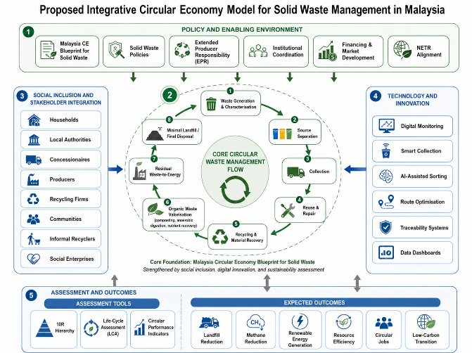
Fig. 6 Proposed Integrative Circular Economy Model for Solid Waste Management in Malaysia
Figure 6 above displays the suggested Integrative Circular Economy Model of Solid Waste Management in Malaysia. The model is based on the Malaysia Circular Economy Blueprint for Solid Waste and includes some of the components of the existing circular economy models and frameworks such as waste hierarchy, social inclusion, digital innovation, and sustainability evaluation. The strategy comprises five important elements: policy and enabling environment, core circular waste management flow, social involvement and stakeholder integration, technology and innovation, and assessment and outcomes.
The first is policy and enabling environment, setting the institutional framework for the implementation of the circular economy. This includes Extended Producer Responsibility, institutional coordination, funding and market development, solid waste regulations, Malaysia Circular Economy Blueprint for Solid Waste and compatibility with the National Energy Transition Roadmap. The layer ensures the proposed approach is in accordance with Malaysia’s sustainability objective and national policy direction.
The second element represents the basic circular waste management flow. Creation and characterisation of waste, then separation at source, collection, reuse and repair, recycling and material recovery, valorisation of organic waste, waste-to-energy as a last resort, and landfill or final disposal only in a minimal way. This order is consistent with the hierarchy of the circular economy that puts waste prevention, reuse, recycling and organic recovery ahead of residual trash for energy recovery or disposal. In this model, waste-to-energy is not the main circular economy strategy but rather a residual channel for non-recyclable waste.
The third component is the integration of stakeholders and social inclusion. The circular economy must be implemented by households, local government, concessionaires, producers, recycling companies, communities, informal recyclers and social entrepreneurs. This component adds to the model by identifying circular waste management as a technical process, but also as a social and institutional process, depending on stakeholder engagement, behavioural change and inclusive involvement.
The fourth element is innovation and technology such as digital monitoring, intelligent collection, AI-assisted sorting, route optimisation, traceability systems and data dashboards. These technologies can improve decision-making, material recovery, trash tracking and collection efficiency. This element is essential to Malaysia’s move towards a more sophisticated and transparent circular waste management system.
The fifth element is assessment and results. This element includes assessment approaches such as the 10R hierarchy, Life-Cycle Assessment and circular performance indicators to analyse the effectiveness of circular economy initiatives. Expected results: reduction of landfill and methane emissions, production of renewable energy, resource efficiency, development of circular jobs, low-carbon transition. The results demonstrate the potential of the proposed methodology to facilitate Malaysia in transitioning to a circular economy and improving energy efficiency.
The overall model indicates that the proposed independent recycling or waste-to-energy projects are inadequate to sustain Malaysia’s transition to circular solid waste management. A successful circular economy model requires policy support, source separation, material recovery, organic waste valorisation, social inclusion, digital innovation, performance evaluation and energy efficiency. The proposed model offers a systematic framework for policymakers, local authorities, solid waste management companies, businesses and communities to develop a more circular, inclusive and low-carbon solid waste management system for Malaysia.
- Conclusion
Malaysia has a strong policy foundation with the Circular Economy Blueprint for Solid Waste and associated policies on source separation, waste minimisation, plastic sustainability and energy transition. However, implementation is still fragmented across stakeholders, technologies and waste streams. This paper develops an integrative model of Circular Economy for solid waste management in Malaysia by integrating the key elements from Asian Development Bank’s waste hierarchy and residual waste-to-energy approach, the Socially Inclusive Circular Economy framework’s social inclusion, the 10R-LCA framework’s sustainability assessment, and digital innovations such as AI-assisted monitoring and smart waste systems.
Waste management is refocused from its generation and separation at source to its reuse, recycling, organic recovery, and finally waste-to-energy with minimal use of landfill, giving priority to higher value recovery options. It has five components, namely: policy and enabling environment, core circular waste flow, social inclusion and stakeholder integration, technology and innovation, and assessment and outcomes. Overall, the model emphasises that Malaysia’s transition to a circular economy should be supported by an integrated, coordinated and evidence-based system rather than discrete initiatives, to reduce dependence on landfills, improve resource efficiency, better recover renewable energy, and align with national low-carbon and energy transition goals.
This project will continue data collection. Semi-structured interviews with the relevant experts and stakeholders will be conducted to empirically evaluate the proposed Integrative Circular Economy Model for Solid Waste Management in Malaysia. The model comprises key dimensions such as policy and enabling environment, circular waste management processes, stakeholder integration, technology and innovation, and performance results. The model will be used as a benchmark and as a guiding framework for the construction of interview questions and for the evaluation of results. The model will be examined for its applicability and implementation challenges, and its elements will be improved based on the comments of policy makers, local government officials, business leaders, and community people.
- Acknowledgement
The authors would like to acknowledge the support provided by the Pusat Pengurusan Penyelidikan dan Inovasi (CRIM) Universiti Teknikal Malaysia Melaka (UTeM), for funding this paper under project number PJP/2025/FPTT/PERSPEKTIF/SA0075. The authors also gratefully acknowledge the financial support and facilities provided by the Fakulti Pengurusan Teknologi dan Teknousahawanan and the Centre of Technopreneurship Development (Cted), UTeM, for their direct and indirect contributions.
REFERENCES
- Al-Waked, R., Alassaf, Y., & Rumman, Y. (2026). The municipal solid waste story in Jordan: Amman as a case study. Materials Research Proceedings, 64, 1161–1173. https://doi.org/10.21741/9781644904091-143.
- Asian Development Bank. (2020). Waste to energy in the age of the circular economy: Best practice handbook.
- Boston Consulting Group. (2018, November 13). Tackling the 1.6-billion-ton food loss and waste crisis. UNECE-FAO Conference, Palais des Nations, Geneva, Switzerland.
- Dzreke, S. S., & Dzreke, S. E. (2026). The metabolic closure: A life cycle theory of waste valorization and the circular economy transition. Engineering Science & Technology Journal,7(6), 243–260. https://doi.org/10.51594/estj.v7i6.2292.
- Economist Intelligence Unit. (2018). Fixing food 2018: Best practices towards the Sustainable Development Goals. Barilla Center for Food & Nutrition.
- Granados, M. L., & Adelekan, A. (2026). Towards a socially inclusive circular economy: Evidence from social enterprises in low- and middle-income countries. Business Strategy and the Environment, 1–22. https://doi.org/10.1002/bse.70940.
- Hoffman, W. (2021, September). Circular economy initiatives at UL. UL LLC.
- Idris Abdulkadir Osime. (2026). Assessing Municipal Waste Management Readiness for Circular Economy Transition. EIRA Journal of Multidisciplinary Research and Development (EIRAJMRD), 2(3). 28-34.
- Kawsar, M. M. A., Shamim, K. F., Islam, S., Taqi, H. M. M., Sarker, S., & Ali, S. M. (2026). Total interpretive structural modeling of circular economy enablers in the construction industry: Evidence from Bangladesh. Journal of Intelligent Sustainability and Decision Analytics, 1(1), 58–100. https://doi.org/10.56578/jisda010104.
- Kementerian Perumahan dan Kerajaan Tempatan. (2019). Dasar Kebersihan Negara 2020–2030. Kementerian Perumahan dan Kerajaan Tempatan.
- Kementerian Perumahan dan Kerajaan Tempatan. (2024). Blueprint ekonomi kitaran bagi sisa pepejal di Malaysia 2025–2035. Kementerian Perumahan dan Kerajaan Tempatan.
- Lajara, R. S. (2026). Engineering initiatives in the integration of circular economy principles in Legazpi Food Park, Barangay Bitano, Legazpi City, Albay. International Journal of Research Publications,197(1),406–437.https://doi.org/10.47119/10.47119/IJRP1001971520269036.
- Li, Y. (2026). AI-driven and circular economy-driven refined community solid waste operation model. Journal of Business and Economic Research (JBER), 2(2). https://doi.org/10.63887/jber.2026.2.2.44.
- Malaysian Investment Development Authority. (2021, December). Waste to energy for a sustainable future. MIDA e-Newsletter.https://www.mida.gov.my/waste-to-energy-for-a-sustainable-future/.
- Mazuaansyah bin Mohd Ali Murad, E. (2021, September 8). Malaysia plastic sustainability roadmap: Catalyzing sustainability and circularity towards a new plastic economy. APEC 13th SCSC Conference: Standardisation in Circular Economy for a More Sustainable Trade.
- Ministry of Economy (2023). National Energy Transition Roadmap. Ministry of Economy Malaysia.
- Ministry of Housing and Local Government Malaysia, & Japan International Cooperation Agency. (2006a). Guidelines for source separation of municipal solid wastes. Ministry of Housing and Local Government Malaysia.
- Ministry of Housing and Local Government Malaysia, & Japan International Cooperation Agency. (2006b). Guidelines for formulation of local action plan on waste minimisation. Ministry of Housing and Local Government Malaysia.
- Mthembu, A. S., Xelelo, Z., Nkwenkwe, S., Mangesi, T., & Chitongo, L. (2026). Informal metal recycling and circular economy potential in King Sabata Dalindyebo Municipality: Environmental, socio-economic and systemic dynamics. Waste, 4(2), Article 20. https://doi.org/10.3390/waste4020020.
- Muhammad, S., Khan, M., & Sheikh, T. M. (2026). Public vs. public-private partnership in solid waste management: A circular economy perspective from Wah Cantt, Pakistan. UCCRN Case Study Docking Station. https://doi.org/10.7916/p07s-ht86.
- Nguyen Thi Thuy, H. (2026). Using the KAP model to support legal policy development for circular economy practices in agriculture: A case study from Northern Vietnam. Economics and Policy of Energy and the Environment, (1). https://doi.org/10.3280/epe2026oa22893.
- Praveenkumar, T. R. (2026). Assessing sustainability and circular economy integration in construction and demolition waste management: Evidence from Delhi. Interactions, 247, Article 190. https://doi.org/10.1007/s10751-026-02464-3.
- Rotimi, T. O., Fatile, J. O., Ajulor, O. V., & Hassan, I. K. (2025). Circular economy and sustainable service quality delivery: A study of waste management in Lagos State, Nigeria. Management Science and Information Technology, 2(4), 357–378. https://doi.org/10.22034/ISS.2026.9974.1048.
- Srivastava, A. N., Vuppaladadiyam, A. K., Koroth, R. P., Pfeifer, C., Kaviti, A. K., Fathi, J., Maslan, A., Barmavatu, P., Buryi, M., Pohorely, M., & Sikarwar, V. S. (2026). Circular economy approaches for sustainable waste management: A review on integration of AI, advanced technologies and policy recommendations. Recycling, 11, Article 99. https://doi.org/10.3390/recycling11060099.
- Sudeep, C. B., & Sunil, P. M. (2026). From waste to resource: Embedding circular economy and lean principles in dental practice for sustainable healthcare. Journal of Pierre Fauchard Academy,40(1),126–133.https://doi.org/10.18231/j.jpfa.12943.1770983406.
- United Nations Environment Programme. (2017). Waste management in ASEAN countries: Summary report.
- United Nations Environment Programme. (2021). Food waste index report 2021.

