International Journal of Computer Information Systems and Industrial Management Applications
ISSN 2150-7988 Volume 18(16s) 2026 pp. 1154-1161
https://doi.org/10.70917/ijcisim-2026-xxxx
Article
An AI-Assisted Adaptive Learning Continuity Model for Future-Ready Higher Education in Unstable Digital Environments
Nedal Jaabari¹
1 Department of Information Technology, Palestine Technical University – Kadoorie, Tulkarm, Palestine
¹st nidal.jabari@ptuk.edu.ps
¹https://orcid.org/0009-0002-5179-6400
*Corresponding Author: nidal.jabari@ptuk.edu.ps
Abstract: Universities operating in unstable digital environments face persistent challenges in maintaining educational continuity. The efficiency of online and blended learning is negatively impacted by various issues, including inadequate internet connectivity, disruptions in electrical supply, restricted access to electronic devices, and disparities in digital preparation. The majority of the time, learning management systems like Moodle offer predefined instructional paths with limited adaptive support, although they support material distribution, evaluation, and communication. A model for adaptive learning continuity that is helped by artificial intelligence is proposed in this research for use by higher education institutions that are constrained by technological and infrastructural limitations. Learner profiles, digital accessibility monitoring, suggestions assisted by artificial intelligence, adaptive material delivery, adaptive assessment, remedial learning pathways, and instructor intervention are all incorporated into the concept. It is designed as an adaptive layer that can be connected to an existing LMS. The paper presents the model architecture, main components, operational workflow, and a pilot implementation plan. The proposed model provides a practical foundation for supporting personalized learning, low-bandwidth alternatives, early risk detection, and targeted remedial support in constrained educational environments.
Keywords: Moodle, digital preparedness, adaptive learning, artificial intelligence in education, educational continuity, learning analytics

- Introduction
Digital learning has emerged as an essential component of higher education, especially due to the rapid rise of online and blended learning during critical educational changes [1, 2]. With the provision of tools for course administration, content distribution, assessment, and communication, learning management systems (LMS) offer assistance to educational institutions such as universities [3, 4].
In spite of these advancements, the success of digital learning is contingent upon the availability of dependable internet access, dependable electricity, appropriate gadgets, and sufficient readiness on the part of the learner [5, 6]. There is no guarantee that these circumstances will be present in surroundings that are unstable. It is possible for students to face frequent disconnections from the internet, pauses in their access to electricity, restricted access to their devices, and a diminished capacity to participate in online learning activities [7], [8].
Traditional LMS platforms usually provide the same learning materials, activities, quizzes, and deadlines for all students. This fixed structure may not respond effectively to differences in digital access, prior knowledge, learning pace, and learner needs. The modification of learning content, assessment, feedback, and assistance in accordance with student characteristics and performance can be accomplished through adaptive learning, which can assist in overcoming this constraint [9], [10].
Through the analysis of learner data, the identification of challenges, the recommendation of resources, and the notification of instructors when assistance is required, artificial intelligence and learning analytics can further support adaptive learning [11], [12]. This study presents a model for adaptive learning continuity that is helped by artificial intelligence and is meant for colleges that are functioning under conditions that are unstable in terms of both technology and infrastructure.
- RESEARCH PROBLEM
Universities in unstable digital environments need more than basic online course delivery. Students may experience academic challenges, technical access issues, or both. It is possible for a student to fail to finish an activity due to a lack of comprehension, inadequate internet access, interruptions in electrical supply, or a lack of preparation to use digital technology. The majority of learning management systems (LMS) will save valuable information such as grades, access logs, quiz attempts, and completion records. However, these data are not always converted into adaptive instructional decisions. This is why there is a requirement for an intelligent adaptive layer that is able to analyse data pertaining to learners and make recommendations regarding appropriate support. The main research problem addressed in this paper is the need for an adaptive learning model, supported by artificial intelligence, to maintain educational continuity in institutions facing unstable technology and infrastructure conditions. In institutions that are functioning under conditions that are unstable in terms of technology and infrastructure, how might an adaptive learning model, aided by artificial intelligence, help to maintain educational continuity?
- OBJECTIVES OF THE RESEARCH
This paper aims to:
• propose an AI-assisted adaptive learning continuity model;
• determine which aspects of the model are the most important;
• Explain how the concept can be included in a learning management system (LMS) like Moodle;
• Please show a workflow that is operational for the continuation of adaptive learning.
• Create a plan for the pilot implementation that will be evaluated in the future
- RELATED WORK
Online and blended learning have become important approaches for maintaining educational continuity during normal and emergency conditions [1], [2]. On the other hand, the success of e-learning is contingent upon the quality of the system, the preparation of the learners, the support of the instructors, the quality of the interactions, and the accessibility of the technology [4, 5].
Adaptive learning systems aim to personalize learning according to learner characteristics, performance, and needs [9], [10]. Earlier adaptive educational models emphasized learner modeling, adaptive sequencing, adaptive testing, and resource adaptation [13], [14]. These models typically utilize components such as the Student Model, the Domain Model, the Activity Model, and the Resource Model.
Artificial intelligence and its application in education support intelligent tutoring, automated feedback, learner modelling, prediction, recommendation, and adaptive assessment [11], [12], [15]. Moreover, learning analytics enables teachers to monitor students' progress, identify pupils who are at danger, and make better judgments regarding their education [16], [17].
Many adaptive systems, on the other hand, concentrate primarily on academic performance and presume that learners have consistent access. In situations with limited resources, adaptive systems should also take into account digital accessibility variables such as the reliability of the internet, the availability of electricity, the accessibility of devices, and the requirements for low bandwidth.
- THE METHODOLOGY
This article utilizes an approach known as conceptual design. This article aims to propose a structured AI-assisted model for implementation and testing in future research.
The model was developed based on three sources:
- literature pertaining to adaptive learning, artificial intelligence in education, learning analytics, and educational continuity literature;
- previous empirical findings from Palestinian higher education showing that technological instability and digital readiness affect educational continuity and acceptance of adaptive environments;
- What are the practical prerequisites for combining adaptive mechanisms with a learning management system like Moodle?
Table 1 illustrates the four distinct stages of the design process.
TABLE I
MODEL DEVELOPMENT STAGES
Stage | The description | The output
1 | The identification of problems to educational continuity | List of obstacles, both technological and pedagogical in nature
2 | Determine the needs for adaptable learning environments. | The model includes the following components: individualization of the learner, monitoring, adaptation, and intervention.
3 | Organize the components of the model. | Six-component adaptive model
4 | The implementation of the pilot plan | The proposed testing process will be conducted in a real course setting.
ARTIFICIAL INTELLIGENCE-ASSISTED ADAPTIVE LEARNING CONTINUITY MODEL PROPOSED
It is designed to function as an intelligent adaptive layer that is coupled to a learning management system (LMS). The LMS manages courses, users, materials, quizzes, grades, and logs. The adaptive layer analyses learner data and then recommends appropriate learning actions.
The model includes six main components, summarized in Table 2.
TABLE II
THE FOLLOWING ARE THE PRINCIPAL ELEMENTS THAT MAKE UP THE SUGGESTED MODEL
Component | Main Function | Output as an Example
Module for the Learner Profile | Records the information and development of the learner | Preparation of students, previous quiz results, and current learning status
The instrument is used to monitor digital accessibility. | Tracks access and participation barriers | The issues include insufficient access, a lag in activity, and inadequate connectivity.
Artificial Intelligence-Based Recommendation Engine | Produces decisions that are adaptable | The system includes remedial content, a version designed for minimal bandwidth, and an alarm.
Adaptive Content Delivery Module | The Adaptive Content Delivery Module provides versions of information that are tailored to different needs. | The module includes a summary, a text version, a visual version, and remedial content.
The assessment and remedial module is designed for adaptive instruction. | The quiz outcomes provide valuable insights for learning support. | The following components support teacher monitoring and intervention: the lecture, the remedial track, and the retake.
The Dashboard Module for the Instructor | Supports teacher monitoring and intervention | The system provides information on students in danger, requests to unlock their accounts, and a report on their progress.
- ARCHITECTURE OF THE MODEL
The proposed architecture consists of four layers: Learning Management Layer, Data Collection Layer, AI and Adaptation Layer, and Presentation and Intervention Layer.
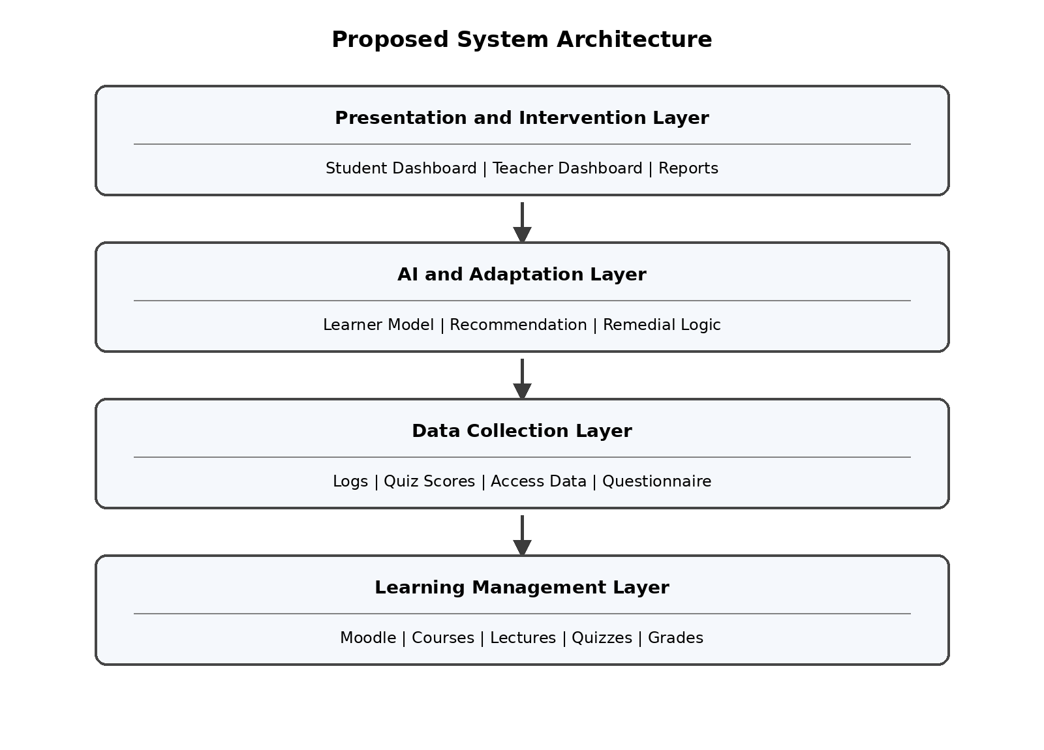
Figure 1 Proposed System Architecture
Through the use of the AI and adaptation layer, the design maintains the Learning Management System (LMS) as the primary educational platform while also including adaptive intelligence. As a result, this concept is feasible because it does not require replacing existing devices and systems.
- MODEL COMPONENTS
- Module for the Learner Profile
The Learner Profile Module stores information about each student, including prior knowledge, digital readiness, quiz performance, learning progress, accessibility limitations, and remedial history. Because the ability to make adaptive judgments is dependent on having reliable learner information, this module is.
- Monitoring Module for Digital Accessibility
This module monitors whether the student can access and continue learning. The system might track your login frequency, the lectures you attend, the activities you don't finish, the quizzes you attempt, the number of times you disconnect, and any access issues you report. The purpose of this endeavor is to differentiate between academic difficulty and technical complexity.
- Ai Recommendation Engine
The AI Recommendation Engine analyses learner data and then recommends appropriate actions. In the first prototype, it can use rule-based logic. Afterwards, it is possible to expand it by utilizing machine learning.
TABLE III
EXAMPLE ADAPTIVE DECISION RULES
The state of | Adaptive Reaction or Act
The student is successful on the test. | Start the next lecture.
A student fails a quiz once. | Launch the corrective content.
The student has two failed quizzes. | Let the teacher know.
This student has limited access. | Offer low-bandwidth material
The student has repeated incomplete activities. | Identify as being in danger
Excellent performance by the student | Open enrichment activity
- Module For Adaptive Content Delivery
This module provides different versions of learning materials according to student needs. The regular lecture, the summary lecture, the text-based version, the visual explanation, the low-bandwidth version, the offline downloading file, the remedial explanation, and the advanced enrichment material are all examples of these variations.
- Module for Adaptive Assessment and Remedial Instruction
The learner is required to complete a brief test following each lecture. The following lecture will be opened up if the student is successful. If the learner is unable to pass, the system will open remedial content that is connected to the topics that they failed. If the student fails again, the instructor is notified.
- Instructor Dashboard and Intervention Module
The dashboard for the teacher displays information about the students' progress, including quiz scores, unsuccessful attempts, access issues, remedial usage, students who are at risk, and unlock requests. However, the method does not take the place of the instructor's academic judgment; rather, it provides support for the instructor.
- THE WORKFLOW FROM OPERATIONS
The model follows a clear learning workflow as in figure 2 bellow:
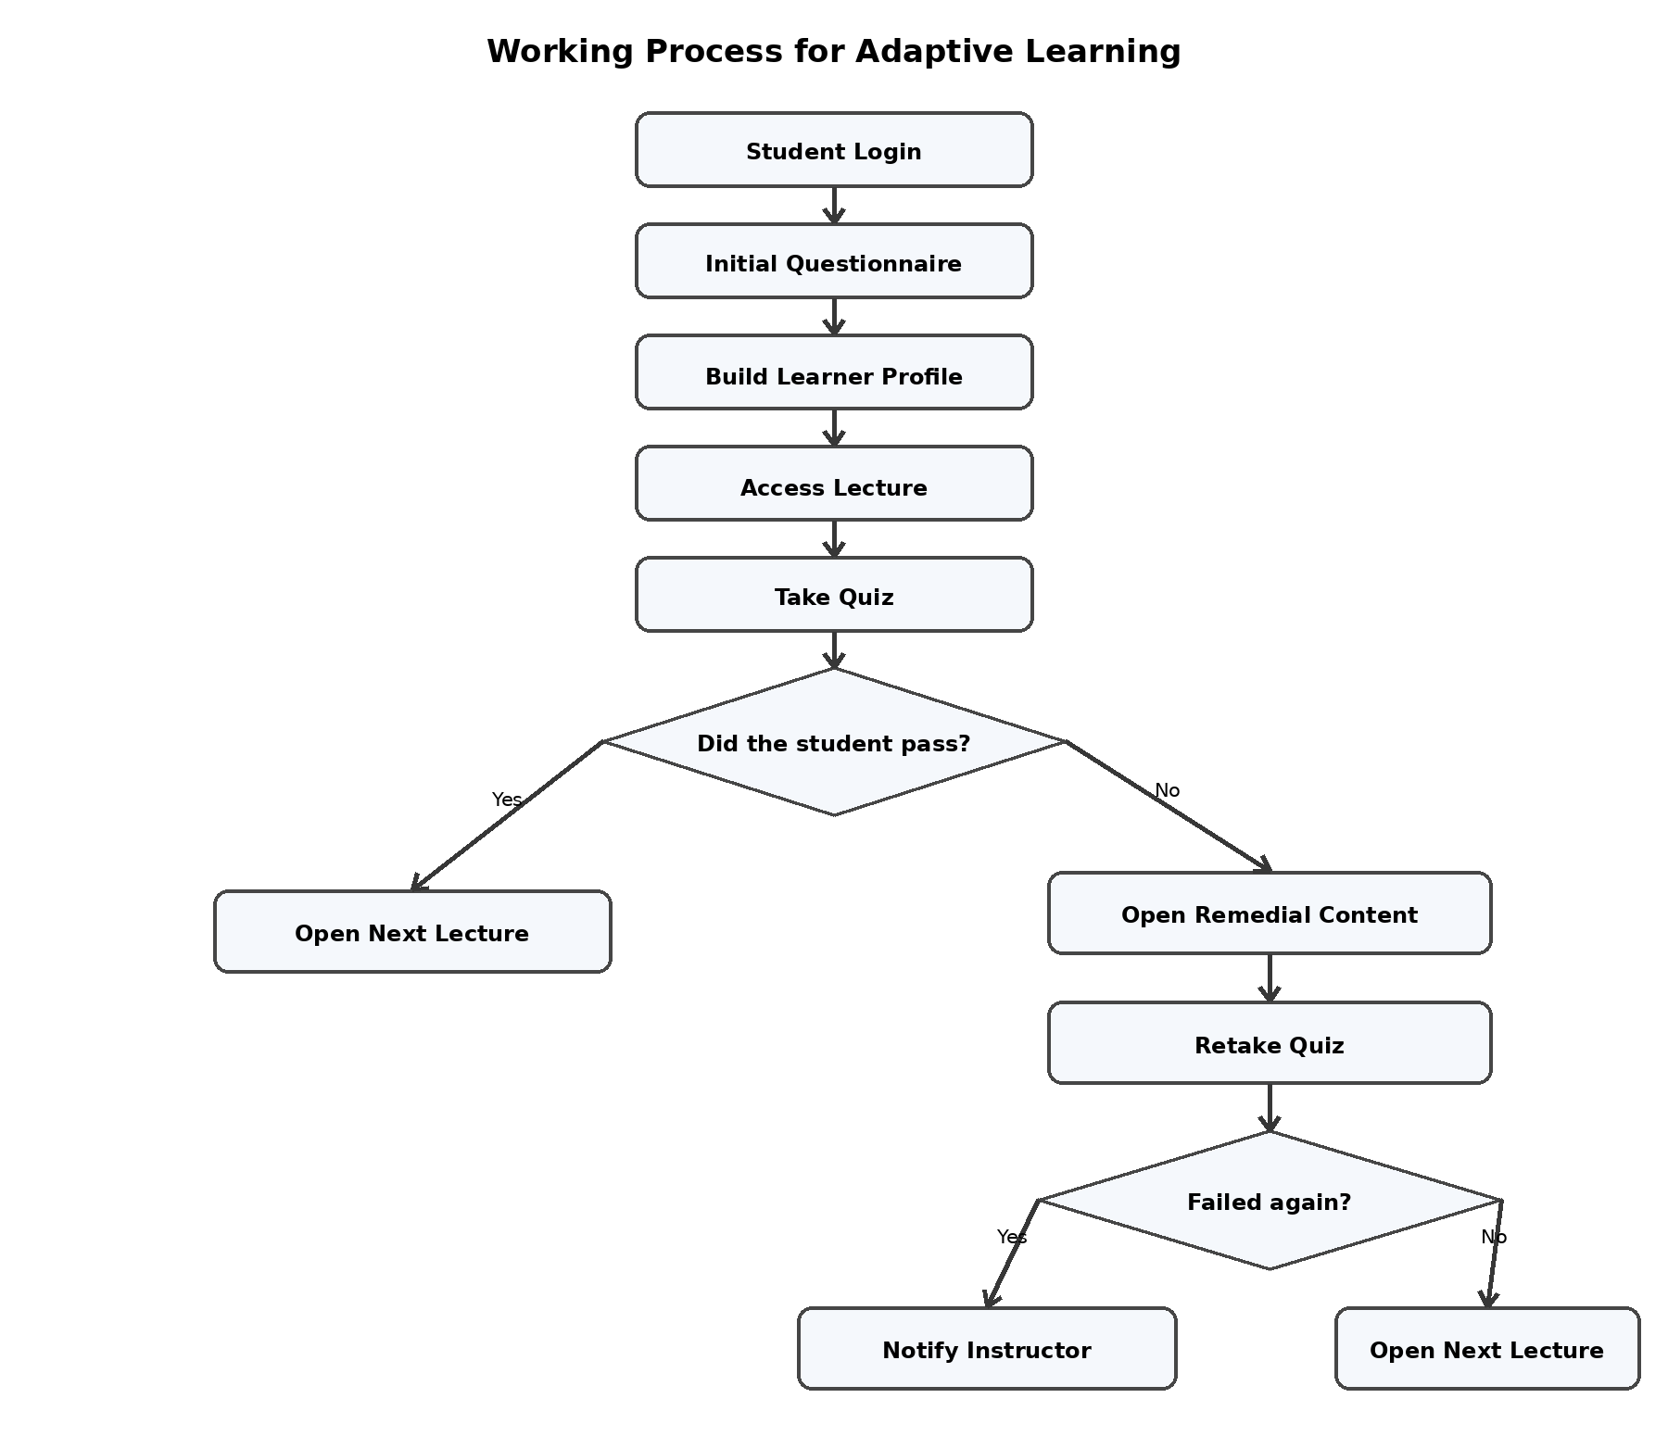
Figure 2 Working Process for Adaptive Learning
In addition to providing students with remedial support before the need for teacher intervention arises, this workflow ensures that students do not progress without having a fundamental comprehension of the ideas required for the next step.
- A PLAN FOR THE PILOT IMPLEMENTATION
The model can be tested through a pilot implementation in one university course. Python can be used as the adaptive processing layer, and Moodle can be utilized as the backend for the learning management system (LMS).
TABLE IV
THE PROPOSED PLAN FOR THE PILOT IMPLEMENTATION PHASE IS OUTLINED IN THE FOLLOWING DESCRIPTION
Phase | The description | The output
Phase 1 | Organize the course materials, including lectures, quizzes, and topics for remediation. | Adaptive-structured training program
The second phase | Collect initial student data through a questionnaire. | Primitive profiles of the learners
Phase 3 | Conduct an experiment of adaptive learning. | Recordings of student interactions
Phase four | Utilize the instructor dashboard to monitor student activity. | Progress and risk reports
Phase 5 | Take a look at the pilot. | Performance, usability, and overall pleasure are the outcomes.
A range of metrics, including completion rate, quiz pass rate, improvement after remedial content, number of instructor interventions, student satisfaction, teacher satisfaction, and usability, can be utilized to quantify the effectiveness of the pilot program.
The proposed model is expected to provide several benefits:
• improvements in the continuity of learning in the face of unstable digital conditions;
• support that is more robust for students who have limited access to the internet or electricity;
• Pathways of learning that are individualized;
• Early detection of children at risk is essential.
• targeted remedial support in relation to unsuccessful notions;
• The data from the LMS should be used more effectively to inform instructional decisions.
• Coordinated warnings and reports minimized teachers' workload.
- TALKING POINTS
The proposed model addresses a practical gap in conventional LMS-based learning. Many learning management systems (LMS) platforms offer minimal adaptive support, although they are effective for managing courses. To make recommendations for appropriate learning actions, the model that has been presented includes an intelligent layer that makes use of learner data, accessibility indications, and quiz outcomes.
The approach considers both academic and technical obstacles. It is possible that connectivity issues, rather than a lack of enthusiasm, are the cause of low involvement in digital environments that are unstable. Therefore, the model monitors accessibility indicators in addition to learning performance.
Moreover, gradual introduction is an additional advantage. You can utilize rule-based adaptation in the initial version, as it is simpler to construct and easier to explain. When sufficient data becomes available, machine learning and predictive analytics can enhance the system.
As an additional benefit, the model maintains the instructor's position. Artificial intelligence is capable of monitoring, making recommendations, and providing early warnings; yet, the instructor retains authority for the ultimate academic intervention.
- LIMITATIONS
On the other hand, this work only describes a conceptual model and does not report any implementation results. As a result, it is recommended that future research construct a prototype that is viable and then test it in a real-world setting.
One such drawback is that the initial version of the artificial intelligence component might make decisions based on sets of rules. It is possible that this approach allows for less customization than more complex machine learning models, despite the fact that it is practical.
The model also requires reliable data collection and careful attention to privacy, ethics, and institutional policy.
- FINAL THOUGHTS
The purpose of this research was to offer an artificial intelligence-assisted adaptive learning continuity model for universities that operate in digital environments that are unstable. The model integrates learner profiling, digital accessibility monitoring, AI-supported recommendation, adaptive content delivery, adaptive assessment, remedial learning, and instructor intervention.
Using the technologies that are currently accessible, the suggested model can be gradually implemented and coupled to existing learning management system (LMS) platforms such as Moodle. It provides a practical framework for improving educational continuity, supporting personalized learning, identifying students at risk, and offering low-bandwidth and remedial learning alternatives.
Future research should focus on developing a prototype, conducting a pilot implementation, and evaluating the model using student performance, completion rates, satisfaction, usability, and teacher feedback.
ACKNOWLEDGEMENT
The author would like to sincerely thank Palestine Technical University – Kadoorie for its financial support in conducting this research and for its continuous support of scientific research in general.
REFERENCES
- M. Bond, S. Bedenlier, V. I. Marín, and M. Händel, “Emergency remote teaching in higher education: Mapping the first global online semester,” Int. J. Educ. Technol. Higher Educ., vol. 18, no. 1, pp. 1-24, 2021.
- J. Crawford, K. Butler-Henderson, J. Rudolph, M. Glowatz, R. Burton, P. Magni, and S. Lam, “COVID-19: 20 countries' higher education intra-period digital pedagogy responses,” J. Appl. Learn. Teach., vol. 3, no. 1, pp. 1-20, 2020.
- D. R. Garrison, T. Anderson, and W. Archer, “Critical inquiry in a text-based environment: Computer conferencing in higher education,” Internet Higher Educ., vol. 2, no. 2-3, pp. 87-105, 2000.
- D. Al-Fraihat, M. Joy, R. Masa'deh, and J. Sinclair, “Evaluating E-learning systems success: An empirical study,” Comput. Human Behav., vol. 102, pp. 67-86, Feb. 2020.
- P. C. Sun, R. J. Tsai, G. Finger, Y. Y. Chen, and D. Yeh, “What drives a successful e-learning? An empirical investigation of the critical factors influencing learner satisfaction,” Comput. Educ., vol. 50, no. 4, pp. 1183-1202, 2008.
- A. Tarhini, K. Hone, and X. Liu, “Measuring the moderating effect of gender and age on e-learning acceptance in England: A structural equation modeling approach for an extended technology acceptance model,” J. Educ. Comput. Res., vol. 51, no. 2, pp. 163-184, 2014.
- C. Hodges, S. Moore, B. Lockee, T. Trust, and A. Bond, “The difference between emergency remote teaching and online learning,” EDUCAUSE Rev., 2020.
- A. Bozkurt and R. C. Sharma, “Emergency remote teaching in a time of global crisis due to coronavirus pandemic,” Asian J. Distance Educ., vol. 15, no. 1, pp. i-vi, 2020.
- P. Brusilovsky, “Adaptive hypermedia,” User Model. User-Adapt. Interact., vol. 11, nos. 1-2, pp. 87-110, 2001.
- S. Graf and Kinshuk, “Adaptive learning systems: Foundations and challenges,” Int. J. Emerg. Technol. Learn., vol. 3, no. 1, pp. 1-6, 2008.
- F. P. Ouyang and F. Jiao, “Artificial intelligence in education: The three paradigms,” Comput. Educ.: Artif. Intell., vol. 2, Art. no. 100020, 2021.
- O. Zawacki-Richter, V. I. Marín, M. Bond, and F. Gouverneur, “Systematic review of research on artificial intelligence applications in higher education—Where are the educators?,” Int. J. Educ. Technol. Higher Educ., vol. 16, no. 1, Art. no. 39, 2019.
- N. A. M. Jabari, M. Hariadi, and M. H. Purnomo, “Intelligent adaptive presentation and e-testing system based on user modeling and course sequencing in a virtual classroom,” Int. J. Comput. Appl., vol. 50, no. 9, pp. 23-31, 2012.
- M. Hanini, R. Tahboub, and N. Jabari, “Student modeling in adaptive educational chat room,” J. Theor. Appl. Inf. Technol., vol. 58, no. 3, pp. 650-656, 2013.
- E. Kasneci et al., “ChatGPT for good? On opportunities and challenges of large language models for education,” Learn. Individ. Differ., vol. 103, Art. no. 102274, 2023.
- R. S. J. d. Baker and G. Siemens, “Learning analytics and educational data mining,” in Proc. 2nd Int. Conf. Learning Analytics and Knowledge (LAK), 2012, pp. 252-254.
- C. Romero and S. Ventura, “Educational data mining and learning analytics,” IEEE Trans. Syst., Man, Cybern. C, Appl. Rev., vol. 40, no. 6, pp. 601-618, Nov. 2010.

