International Journal of Computer Information Systems and Industrial Management Applications
ISSN 2150-7988 Volume 18(16s) 2026 pp. 1295-1310
https://doi.org/10.70917/ijcisim-2026-xxxx
Article
Exploring the Role of Artificial Intelligence in Entrepreneurial Education
Vivaan Mehta
Podar International School, Mumbai
vivaanm30@gmail.com
Abstract: The growing use of artificial intelligence in higher education is reshaping entrepreneurship education, a field which was traditionally built on experience-based learning and mentorship. This study investigates how AI technologies such as personalised learning systems, generative AI, natural language processing (NLP), AI-powered incubators, and hybrid teaching models, are able to influence the development of skill for entrepreneurs, help adapt academic curriculums to the ever-changing growth of technologies, and help support practices within their facilities. A qualitative methodology was adopted using a structured review of literature from references such as Scopus, Web of Science (WoS), the Australian Business Deans Council (ABDC) Journal Quality List, and the IEEE Xplore Digital Library. The findings of the research were supported by evidence from educational institutions from references such as McKinsey & Company, Deloitte, Harvard Business Review, Statista, and Gallup. The study draws on constructivist learning theory, self-determination theory, and innovation ecosystem frameworks. Furthermore, the analysis is guided by three main research questions, how AI based personalised learning affects entrepreneurial competencies, how generative AI and NLP tools support innovation and Sustainable Development Goal (SDG) related outcomes, and how AI supported teaching models are changing entrepreneurship education in universities. A brief analysis of themes and case study evidence were used to examine these areas. Therefore, these findings suggest that AI strengthens both technical and interpersonal entrepreneurial skills which supports sustainable innovation and enhances entrepreneurial activities within universities. Based on these findings, the research proposes the AI Integrated Entrepreneurship Learning (AIEL) framework which provides practical guidance for educators, policymakers, and curriculum designers who plan to integrate AI for their academic curricula and help support future entrepreneurial development.
Keywords: AI in education; entrepreneurship education; personalised learning; generative AI; sustainable development goals

1. Introduction
“Predicting the future isn’t magic, it is artificial intelligence,” (Dave Waters) this perfectly displays the predominant use of AI in today’s day and age. AI plays an important role in strengthening entrepreneurial education by helping students develop innovative thinking to start ventures. Studies suggest that AI acts as a bridge between entrepreneurial knowledge and real innovation in order to help future entrepreneurs to reach their desired goals. According to McKinsey, up to 30–32% of current work activities could be automated by 2030, significantly altering workforce structures and entrepreneurial pathways. Through tools that help with experiential learning and problem solving. AI therefore eradicates several technical barriers that students often face which allows them to focus on decision making and creativity. AI aids students by providing help in real life situations by applying entrepreneurial knowledge. By simplifying complicated technology, which allows students to test, analyse errors, and find solutions easily. Therefore, AI can change entrepreneurial training into actionable skills and help create an innovative environment. However, to use AI in entrepreneurial education effectively, one requires a balanced approach towards its use. While having good technological knowledge, students are required to have strong information literacy as well as good ethical awareness in order to use AI responsibly. Once these conditions are met, AI helps provide sustainable and digitally driven entrepreneurship rather than creating overdependence on technology (Zulfiqar et al., 2025).
Similarly, AI is also becoming an important tool for entrepreneurial education at the university level. At higher academic levels, AI aids students in order to support future entrepreneurs for high demanding tasks. After several conducted surveys of undergraduate students, it showcases that AI powered chatbots can help improve efficiency in various activities such as writing business plans and generating start up ideas. Recent global estimates suggest that the AI market is expected to exceed $1.8 trillion by 2030, reflecting its rapid expansion across sectors. Such tools can help boost creativity and make complex academic tasks easier to manage. The use of AI in the academic world also seems to raise various concerns. A major concern is the reliability of AI responses as many responses have provided inaccurate results. Therefore, it makes it difficult for students to rely on its responses without reviewing it. It is important that students approach AI with immense thought and care. Likewise, students must develop the ability to question and verify must be vital in order to ensure that AI helps support learning rather than replacing an individual’s thinking. AI can offer strong academic advantages and help improve efficiency if used responsibly. These conditions need to be considered for universities that want to incorporate a modern business and entrepreneurship curriculum by adding new digital technologies while maintaining academic integrity and independent thinking (Vecchiarini & Somià, 2024). An example of the increasing usage of AI to develop entrepreneurial skills for higher education is South Africa (Ragolane et al., 2025). Their research approach helps students understand how digital tools can aid students to understand business strategies and secure investments. Research indicates that AI can help improve decision making and the quality of funding proposals. They elaborate on a thorough use of human intelligence throughout projects in order to maintain ethics.
AI is being significantly incorporated in tools such as machine learning and big data which help in tasks such as student assessment and the ability to identify opportunities. The integration of AI into education is expanding rapidly, with reports indicating that over 60% of higher education institutions in developed economies are experimenting with AI-enabled learning tools. For facilitators, AI can reduce workload and increase efficiency in the learning process. As useful as these technologies are, they still require advanced teaching methodologies in order to target better learning capabilities and outcomes (Chen et al., 2024). In current times, educators are being encouraged to shift the use of onto supporting the exploration of intelligent systems in order to provide deeper learning. These tools have the ability to help different stages of the entrepreneurial processes rather than performing routine tasks. Through these possibilities, there are significant benefits of AI systems in entrepreneurial education. AI has proved to be advantageous in several Indian start-ups as it provides a competitive edge by driving innovation and management. The use of advanced technologies is helping businesses improve product development and increase the efficiency of business operations in sectors such as fintech, healthcare, and education. The Dynamic Capabilities Theory, Resource Based View, and the Disruptive Innovation Theory, the analysis explains how AI improves innovation and gives Indian start-ups a competitive advantage through real life examples. This can help policy makers and business strategists to support long term growth and to maintain competitiveness (Singh et al., 2025).
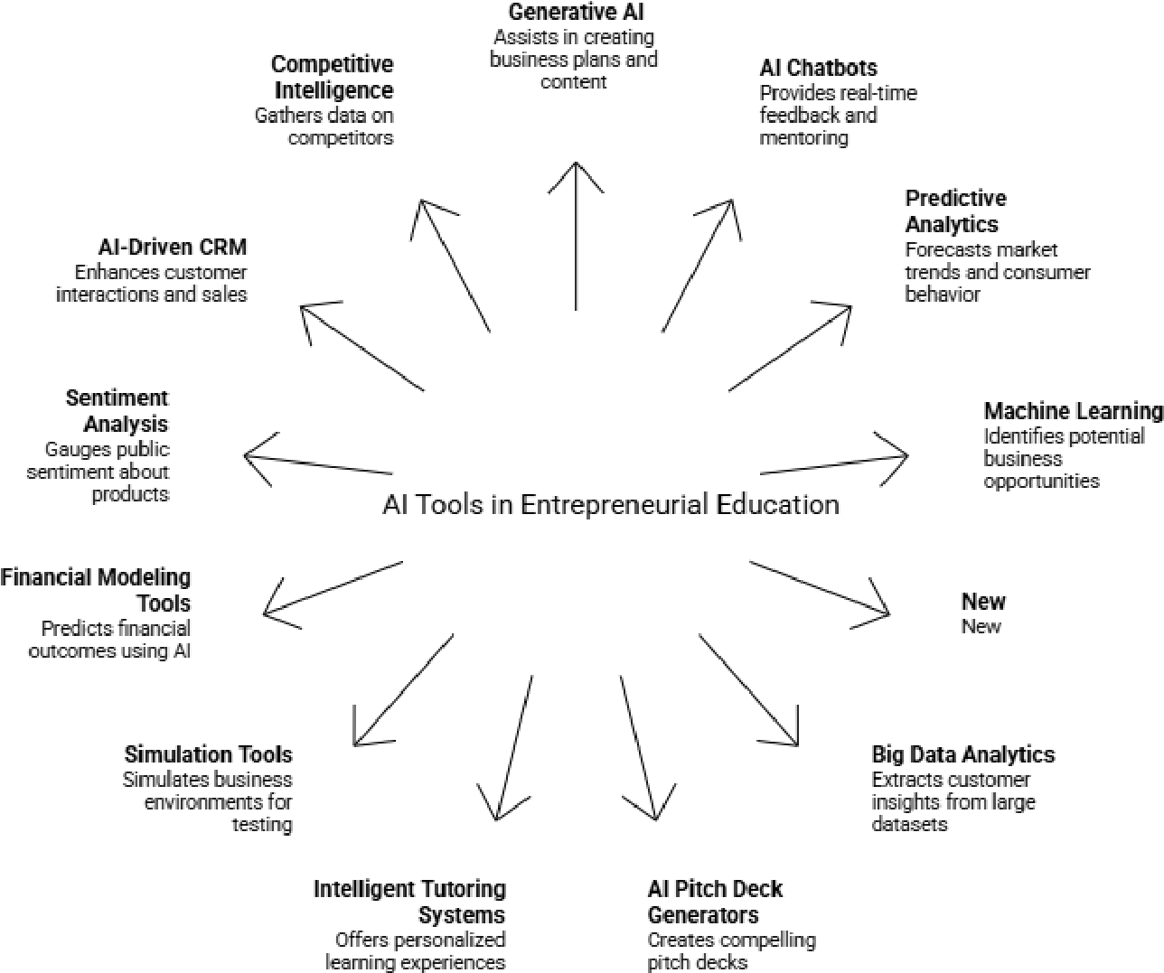
Figure 1: Artificial Intelligence entrepreneurial education to improve creativity, problem solving, and decision making
A factor that is increasing the influence of entrepreneurial education is generative AI. Even though there is a lack of research on how it can be used effectively, it still has great potential to change the structure of teaching methods and curriculums. Therefore, educators are encouraged to endorse these tools so that students can develop technical and reflective skills for future businesses. There is also a need to address challenges related to the changing nature of teaching practices. Finally, it is a call for action to incorporate AI to prepare entrepreneurs for a new age economy (Bell & Bell, 2023).
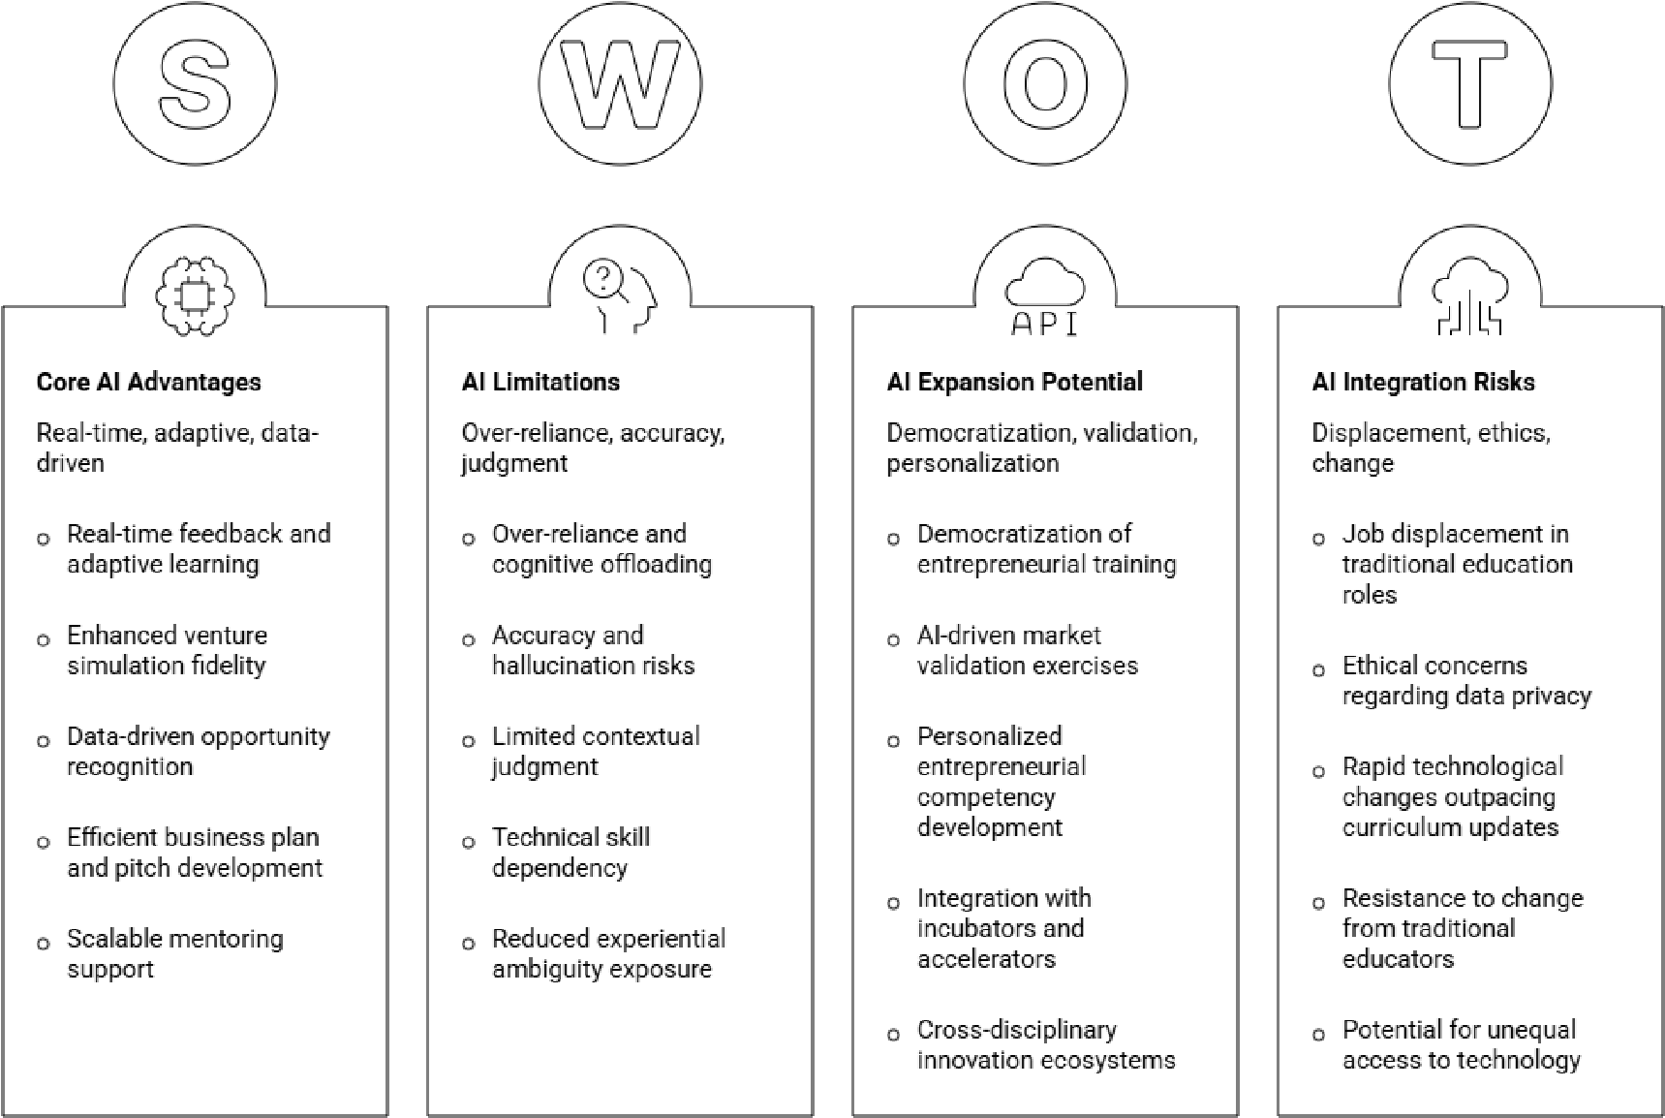
Figure 2: AI incorporated in entrepreneurship programs showing SWOT analysis
In Universities, AI has played a great role in reshaping entrepreneurship education leading to many institutions rethinking their teaching strategies. The fast-paced growth of AI has influenced various traditional sectors while creating new ones. Therefore, entrepreneurship education now has begun integrating AI into its newly designed curriculum. Universities are now incorporating ethical education and innovating thinking into their programs. Many curriculums are now in support of this shift by partnering with many industries, establishing incubators and creating a strong balance between theoretical learning and real-world practice. In this way, students will be able to make use of AI technologies while also applying practical skills. It also builds strong morals of ethical awareness and social responsibility. These changes aim to create entrepreneurs ready for the new AI era which prepares them to develop, innovate, and adapt for the unforeseen future (Mu & Zhao, 2024). In modern business schools the way generative AI is increasing in its growth is changing the way entrepreneurship is taught. Even if current AI platforms may perform below human levels technically, their rapid development enforces facilitators to move towards the use of AI tools. Learning these skills can help future entrepreneurs develop the ability to survive in uncertain and competitive environments. On the contrary, universities are still struggling to fit these tools into their curriculum in order to ensure consistent results for students. Educators also need to assess how environmental and human factors can affect the use of AI in entrepreneurial skills successfully (Gong et al., 2025). AI also provides advanced tools that facilitate personalised learning and improve institutional management. AI is also shaping entrepreneurship training through the use of simulated environments and real time feedback systems that foster student innovation. In developing regions such as Africa, the traditional method of teaching often struggles to address the high level of youth unemployment, therefore in such regions these technologies could prove to be significant. Using interactive digital platforms, universities can connect academic learnings with real business practices through the change in curriculum. The increase in adoption of AI can drive economic development while also providing access to modern education worldwide(Gong et al., 2025).
This study explores how AI can reshape entrepreneurial education in higher education institutions. This framework fixates on three fundamental areas. Firstly, the research investigates how AI based learning systems such as generative AI and NLP tools can be incorporated into academics to strengthen both technical abilities and to build on essential skills such as communication, adaptability, and ethical decision making. Second, the study explores how personalised and experience-based learning supported by AI can help students apply entrepreneurial ideas in practical contexts while contributing to a greater economic and social development linked to the Sustainable Development Goals (SDGs). Finally, the research analyses emerging developments in AI supported entrepreneurship education, such as AI-driven incubators, hybrid intelligence systems, venture studios, and flipped classroom approaches, in order to understand how universities can adapt their curriculum to meet changing educational and industry demands.
This research paper highlights how AI can be inculcated into entrepreneurship curriculums in order to strengthen student’s skills and career opportunities. It provides a structured research process that commences with teaching methods that incorporate AI and then a supporting theoretical framework. Using various theories and models, the analysis assesses the influence of technology on entrepreneurial training. The paper also presents findings and discussions which aim at shaping future curriculums and teaching strategies. It helps universities understand how machine learning can support business creation for future entrepreneurs.
2. Literature Review
Artificial Intelligence has had a rapid growth in reshaping global value chains and creating a strong need for curricula to adapt. At the moment, economic value is shifting toward innovation, creativity, and decision making due to the ability for AI to automate routine tasks. On the contrary, this may cause greater inequalities between developed and developing economies. Individuals require both technical skills and soft skills such as communication, adaptability, and ethical awareness in order to succeed in an AI driven world. This makes it important for education systems to adopt personalized learning and build stronger links with industry. However, progress may be slowed down due to challenges such as digital inequality, limited access to technology and resistance. It is important to have a collaborative approach between educators, policymakers, and industry to prepare young learners for the changing demands of the future workforce (Dutta et al., 2026). Building on the need for educational change, researchers have also highlighted the importance of creating institutional frameworks that support AI innovation. In order to advance AI innovation in higher education across the Arab region, a strong framework is required. Protecting intellectual property, especially through patents which is important to supporting technology start-ups. To improve regional language models, it is necessary to expand Arabic training data. Universities should create technology transfer units to connect research with industry and help turn ideas into commercial applications. Students can apply innovation in practical settings by incorporating entrepreneurial training into curricula. These steps can help support long term economic and social progress (Al-Omari et al., 2026).
While institutional frameworks are significant for the integration of AI, the role of specific AI technologies in entrepreneurial education is becoming increasingly significant as well. Natural Language Processing (NLP) has started to become relevant in entrepreneurship and small business research, whereas its use in entrepreneurship education is limited. A review journal of over 140 articles found that NLP is mainly used to predict fundraising success, with the common techniques being sentiment analysis and topic modelling. Even though NLP is well established in fields such as finance, its potential in entrepreneurship research is yet unexplored. The review provides a useful foundation for future studies by identifying key trends and gaps. It also highlights new opportunities to integrate into business development and entrepreneurial education, which helps to bridge the gap between practical learning and technological innovation (Šmaguc & Kudelić, 2024). Further than NLP applications, recent studies have discussed the broader implications of AI tools in entrepreneurial pedagogy and student learning. By supporting students in areas such as business modelling, opportunity recognition, and decision making, AI is transforming entrepreneurial pedagogy. By providing faster insights and more personalised support, tools like large language models and predictive analysis can enhance learning. Artificial Intelligence enables adaptive learning environments that cater to individual student needs. However, high dependence on AI tools may cause a decrease in critical thinking and independent reasoning, which are essential for entrepreneurship. To solve this issue, a balanced approach that combines the efficiency of AI with human guidance and ethics in mind is required. These findings showcase the importance of carefully integrating AI into academic curricula while also preserving the depth and quality of entrepreneurial education (Park, 2025).
Similarly, scholars have examined how universities are applying AI driven approaches within entrepreneurship ecosystems and incubation centres. AI is becoming increasingly important in university entrepreneurship education and start-up incubation centres. Tools such as business planning, market analysis, and operational strategies can help students manage complex tasks. This makes the entrepreneurial process more accessible and efficient. Current research indicates that there is still limited understanding of how higher education institutions effectively integrate AI to support student entrepreneurs. By using generative AI tools to strengthen entrepreneurial learning and innovation, universities will be able to adopt a more transformative approach. In order to understand how AI can be used to support young innovators, greater research is needed in both developed and developing countries. This is necessary for aligning academic support systems with the demands of the fourth industrial revolution (Thottoli et al., 2024).
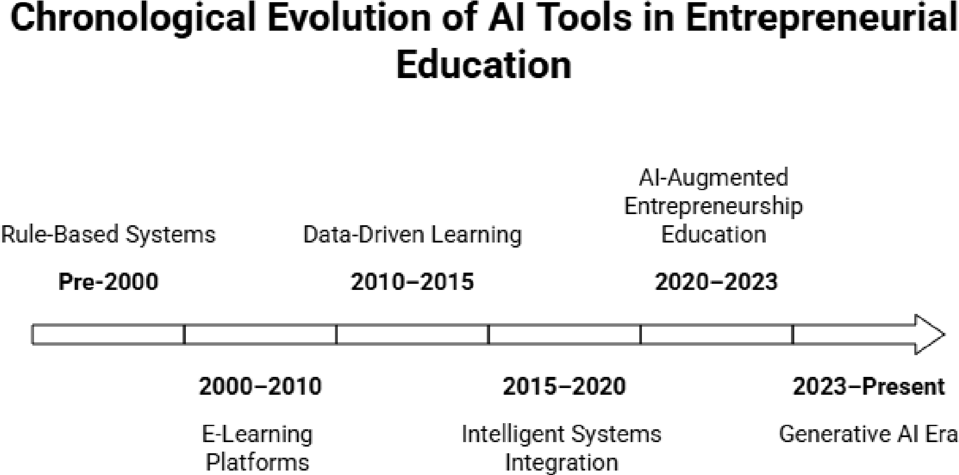
Figure.3 : Chronological development of AI tools in entrepreneurial education.
This technological evolution has encouraged the development of new educational models that combine AI with entrepreneurship and sustainable development. The Multi-Intelligence University Model offers a modern approach to meet the demands of the fourth industrial revolution. It combines artificial intelligence, entrepreneurship, and sustainability to help students develop technical skills and social responsibility. This model can better prepare students for a digital economy, through AI-driven personalised learning and stronger industry partnership. It provides universities a practical framework for aiming to align education with global development goals (Van Tam et al., 2026). In addition to institutional models, researchers have also investigated how AI can contribute to sustainable entrepreneurial education. A review of over 21 articles suggests how generative AI is used in entrepreneurship education to support sustainable development goals (SDG’s). This showcases that AI tools increase entrepreneurial intent by improving student’s skills, confidence, and capabilities. For successful training, a student’s confidence has proved to be significant, while support from universities mattered more than how advanced the AI technology was. This suggests that the advancement of a student does not only depend on AI but also the learning environments provided by universities. However, a major research gap still exists, most studies discuss possible benefits but do not measure real sustainability results. These findings can help improve future teaching methods and research in AI-based entrepreneurial education (Sulistyowati et al., 2026).
Alongside these educational applications, theoretical frameworks have also been brought up to distinguish the relationship between AI and entrepreneurship. The AI Enabled Individual Entrepreneurship Theory (AIET) explains how advanced technology helps entrepreneurs achieve growth and efficiency once limited to large companies. By improving skills, increasing access to capital, and reducing risks, AI enables individuals to compete more effectively in global markets. The model also supports SDGs by promoting equal opportunities, better use of resources, and stronger innovation. However, the theory still poses certain challenges such as unequal access to technology across regions and algorithm bias. AIET offers a practical approach to entrepreneurial education by showing how technology can support sustainable businesses and change traditional business models (Ganuthula, 2025). Finally, recent studies have brought together existing research on AI and entrepreneurial education to identify major trends and future opportunities. A review explores the connection between artificial intelligence and entrepreneurial education by identifying key research trends and major contributors. The study found that China leads in both the number of publications and research impact in this field, by the use of Bibliometric analysis. The review categorises existing studies into three themes, deep learning, adaptive learning models, and ethical issues. It highlights the potential of AI based predictive systems to support the development of modern entrepreneurial skills. These findings can help policymakers and educators use generative technology more effectively in entrepreneurship education (Elsa et al., 2026b).
TABLE I EXTENSIVE LITERATURE REVIEW FOR AI IN ENTERPRENEURIAL EDUCATION
References | Key Findings | Methodology | AI Tools for  Entrepreneurs hip | Limitations
Margaretha et al. (2025) | Entrepreneurs hip education positively impacts outcomes | Quantitative survey (400 business students in Indonesia) | General AI tools integrated into curricula | Uneven  distributio n of education (Java-centr ic bias)
Menyaoui &  Habacha  (2025) | AI enhances creativity and entrepreneuria l intention | Quantitativ e survey (312 students) | ChatGPT,  Copilot, Gemini, recommendatio n systems | Cross-secti onal design limits causality
Alpürk et al.  (2025) | Identifies 5 themes including pedagogical innovation | Bibliometri c analysis +  LDA  modeling | Generative AI, machine learning tools | English-la nguage bias; citation lag
Bell & Bell  (2023) | AI can amplify | Conceptual discussion | ChatGPT, Bard  (Gemini), | Concerns over
 | creativity in education | + literature review | ERNIE, Tongyi  Qianwen | assessment integrity
Khavasi  (2025) | AI + FLIP learning improves engagement | Qualitative case study | ChatGPT as learning assistant | Risk of over-relian ce; ethical concerns
Somià &  Vecchiarini  (2024) | ChatGPT  boosts 5 entrepreneurial  competencies | Mixed methods (survey + interviews) | ChatGPT for business idea development | Research gap on long-term effects
Ragolane  (2025) | AI improves efficiency in academic tasks | Qualitative literature synthesis | ChatGPT,  DALL-E,  Grammarly, ResearchBuddie | Infrastruct ure and staff limitations
Pastarmadzhi eva & Angelova  (2025) | AI enables personalized education | Desk research | ChatGPT, Edthena, business simulators | Loss of human  analytical skills
Szumska &  Weixler  (2024) | Readiness depends on  institutional factors | Semi-struct ured interviews | Copilot,  ChatGPT,  Gemini | Policies struggle to keep up with AI growth
3. Research Methodology
This study uses a qualitative research approach based on a literature review and case study analysis. Academic sources were collected from four main databases: Scopus, Web of Science (WoS), the Australian Business Deans Council (ABDC) Journal Quality List, and the IEEE Xplore Digital Library, allowing the research to cover business, education, and technological perspectives. In addition to academic journals, industry reports and statistical data from sources such as the Harvard Business Review, Gallup, Statista, McKinsey & Company, and Deloitte were used to provide insights into current educational and entrepreneurial trends. The selected case studies were linked to each of the three research questions, making it possible to compare them to themes related to personalised learning, curriculum development, and new AI supported teaching methods. By combining academic research, industry evidence, and case studies, the study aims to maintain both academic reliability and to ensure it is relevant to today’s day and age.
Research Questions -
- How do AI based personalised learning systems affect the development of a student's entrepreneurial skills, including both technical and soft skills?
- How does the use of generative AI and NLP tools in entrepreneurship education support practical learning, innovation, and sustainable development goals (SDGs)?
- What new AI-supported teaching models, such as AI-powered incubators and flipped classrooms, are influencing the future of entrepreneurship education in universities?
Hypothesis -
- H1- Students learning through AI-based personalised learning systems are likely to show stronger entrepreneurial skills, including both technical abilities and soft skills, than students in traditional learning environments.
- H2 - Entrepreneurship courses that use generative AI and NLP tools are expected to improve innovation, practical entrepreneurial skills, and awareness of opportunities connected to the Sustainable Development Goals (SDGs).
- H3 - Universities that adopt AI-supported teaching methods, such as AI-powered incubators and hybrid learning systems, are more likely to encourage higher levels of student entrepreneurship and start-up creation.
This study uses a qualitative research approach based on a literature review and case study analysis. Academic sources were collected from four main databases: Scopus, Web of Science (WoS), the Australian Business Deans Council (ABDC) Journal Quality List, and the IEEE Xplore Digital Library, allowing the research to cover business, education, and technological perspectives. In addition to academic journals, industry reports and statistical data from sources such as the Harvard Business Review, Gallup, Statista, McKinsey & Company, and Deloitte were used to provide insights into current educational and entrepreneurial trends. The selected case studies were linked to each of the three research questions, making it possible to compare them to themes related to personalised learning, curriculum development, and new AI supported teaching methods. By combining academic research, industry evidence, and case studies, the study aims to maintain both academic reliability and to ensure it is relevant to today’s day and age.
Q1- How do AI based personalised learning systems affect the development of a student's entrepreneurial skills, including both technical and soft skills?
The swift development of artificial intelligence from early expert systems to large language models and generative AI has significantly changed the possibilities of teaching and learning in higher education systems. Recent studies indicate that AI supports personalised learning, instant feedback, or adaptive content delivery on a large scale. This is often significant in entrepreneurial education as learning is often experimental where problem solving, trial and error are practiced regularly. Therefore, AI systems are proved to be useful tools for the entrepreneurial learning process (Fortuna et al., 2025). On top of this shift, generative AI is being incorporated into entrepreneurship classrooms as learning aids and idea generation instruments, tools such as ChatGPT are becoming popular amongst classrooms. Studies done in higher education institutions in the Middle East suggest that ChatGPT positively influences students’ interest in entrepreneurship and start-up creation. However, in formal entrepreneurship education its impact may be limited. This illustrates that AI strengthens motivation, confidence, and entrepreneurial thinking rather than developing entrepreneurial expertise (Fortuna et al., 2025). More than motivation and idea generation, AI powered educational platforms contribute to the development of technical entrepreneurial skills. AI systems such as learning management systems (LMS) use student performance data to provide customised learning pathways, helping learners improve abilities such as financial planning, opportunity recognition, and strategic thinking at their own pace. Such systems are often used in professional training environments where personalised learning modules have augmented employee performance, knowledge retention, and the ability for them to meet the business’s objectives(Katiyar et al., 2024) .
In addition to personalised learning systems, AI based innovation tools have also strengthened entrepreneurial decision making and adaptability. Students and entrepreneurs have often benefited from tools that combine AI with patent analysis and innovation intelligence which allows them to identify market opportunities easily. Studies based on dynamic capability theory suggest that AI supported innovation systems improve an entrepreneur’s ability to recognise opportunities, respond to changes, and adapt their business strategies. These skills are significant in modern entrepreneurial environments due to rapid technological change (Katiyar et al., 2024). Another important area of AI integration in entrepreneurship education is simulation-based learning. Platforms such as SimVenture give students a platform with realistic business environments where they can practice decision making, financial planning, and risk management. Studies indicate that these simulations improve entrepreneurship education outcomes, particularly in areas such as business modelling and financial reasoning. Although simulation tools may not directly increase an individual’s psychological drive to start a business, they strengthen the practical capabilities that indirectly encourage entrepreneurial activity. This highlights the importance of experiential learning in entrepreneurship education.
While AI tools are effective in developing technical competencies, they also play a role in supporting soft skills that are essential for future entrepreneurs. Skills such as leadership, communication, teamwork, creativity, and resilience are often difficult to teach through traditional classroom methods. AI powered talent development systems provide students with opportunities to practice these abilities in realistic but low risk settings through the use of technologies such as natural language processing, deep learning, and augmented reality. Students are exposed to situations that reflect real entrepreneurial challenges, through simulations and personalised feedback (Anector et al., 2025). Similarly, generative AI systems are increasingly being linked to the development of higher order thinking skills in entrepreneurship education. Research grounded in constructivist and social cognitive theories suggests that these systems can support critical thinking, ethical reasoning, and creative problem solving when used effectively in the classroom. Existing studies identify four major areas where generative AI contributes to entrepreneurial learning: personalised instruction, simulation-based learning, ethical awareness, and intelligent ecosystem integration. Together, these areas contribute to the development of important soft skills for entrepreneurs (Anector et al., 2025). The influence of AI on entrepreneurship education is particularly significant in emerging market economies, where innovation and adaptability are critical for business survival. Studies illustrate that AI driven systems not only improve technical abilities but also strengthen resilience, flexibility, and the capability to organise among entrepreneurs and students. These qualities are especially valuable in uncertain and rapidly changing business environments, where entrepreneurial leadership depends on both adaptability and strategic thinking (Anector et al., 2025). To better understand these findings, table one provides a comparison of 7 major studies across the different research question categories. It is sectioned in 3 categories, the AI tools used, the development competency, and its evidence from literature.
TABLE II RQ THEMES, LITERATURE EVIDENCE AND AI MECHANISM USED
RQ Theme | Evidence from  Literature | Competency  Developed | AI  Tool/Mechanism
Adaptive  personalisation in HE | AI shifts to ML, NLP, LLMs; adaptive pathways, real-time feedback (ScienceDirect, 2025) | Self-directed learning; metacognitive awareness | LMS with ML algorithms; ChatGPT
Entrepreneurial skill building via AI | AI talent dev integrates AR/VR, blockchain; personalized skill-gap analysis (ResearchGate,  2024) | Leadership; opportunity recognition; innovation | AI-driven talent platforms
GenAI in entrepreneurship education (EE) | GAI maps to adaptive instruction & simulation-based training; constructivism-grounded (ScienceDirect, 2025) | Critical thinking; decision-making; creativity | ChatGPT; GAI tutors
Simulation-based entrepreneurial learning | SimVenture improves EE outcomes; indirect boost to start-up intention via outcomes (ResearchGate,  2024) | Risk-taking; business modelling; teamwork | SimVenture AI simulation
AI-driven innovation & organisational resilience | Entrepreneurial cognition drives AI innovation; dynamic capability theory  (MDPI, 2025) | Strategic thinking; adaptive capability | AI patent-driven innovation tools
AI for economic dev  & startup ecosystems | AI enhances efficiency, market opportunity, decision-making in Indian startups (ResearchGate,  2025) | Opportunity recognition; market orientation | AI analytics; decision-support systems
Corporate AI training personalisation | AI tailors modules to skill gaps, performance metrics; boosts retention  (SSRN, 2025) | Soft skills:  communication, collaboration, agility | Corporate AI LMS; adaptive content engines
The table illustrates that different AI tools contribute to different areas of entrepreneurial education. The most effective use in AI seems to be in improving motivation and improving soft skills, while simulation-based learning platforms help strengthen technical and practical competencies for entrepreneurs. Similarly, machine learning adaptive systems tend to be effective whilst supporting independent and self-paced learning. This suggests that entrepreneurial training benefits the most from the combination of several AI tools rather than the reliance on anyone (Lei et al., 2025). Despite these benefits, studies continue to illustrate the gap between AI tools and the long-term outcomes for entrepreneurs. Most outcomes focus on short term goals such as student engagement, knowledge improvement or an increase in intentions for entrepreneurs rather than long term goals such as venture goals, stability of a business, or having a successful startup creation. Therefore, future studies may need to incorporate longitudinal and mixed method research approaches to better evaluate the impact of AI on entrepreneurial education (Awad et al., 2024).
In conclusion, for the wider adaptation of AI in education, ethical and accessibility concerns remain major challenges. Several issues may limit the effectiveness of AI-driven learning systems, challenges such as algorithmic bias, data privacy risks, and unequal access to digital infrastructure may limit its effectiveness especially in low-income regions. Therefore, the expansion of AI supported entrepreneurship education must include ethical guidelines, responsible data practices, and equal access to technology to ensure that the benefits of AI are distributed more fairly across different educational contexts (Awad et al., 2024).
Q2- How does the use of generative AI and NLP tools in entrepreneurship education support practical learning, innovation, and sustainable development goals (SDGs)?
This case study forms a part of the present mixed methods research. It was designed to examine how Generative AI (GenAI) and Natural Language Processing (NLP) tools are being incorporated into the curriculum of entrepreneurship education and whether their use supports experiential learning, innovation in teaching practices, and outcomes linked to the United Nations Sustainable Development Goals (SDGs). The case was selected through purposive sampling which focuses on an institution whose documented AI adoption process and faculty level Technology-to-Performance Chain (TPC) data provided insights on the usefulness of AThe institution which is selected is a graduate business school in a middle-income economy where several entrepreneurship and innovation management courses over a two-year period were introduced to generative AI. This extended time frame helped researchers track the shift from early refusal of use to an established use in the school which provides a clear understanding of how entrepreneurship education settings evolve with the incorporation of AI .
Therefore, the study emphasised on 26 faculty members across different entrepreneurship related programs. For tools to improve idea generation and problem solving, the faculty integrated tools such as large language models into classroom activities which allowed students to comprehend business concepts and create venture proposals more efficiently within limited class time. Additionally, to provide automated feedback on business model assignments NLP, systems were used which enabled instructors to dedicate more time to mentorship and higher-level guidance. To better understand these teaching practices, qualitative data were collected through interviews and supported by documentary analysis of the course’s syllabus and AI policies in their curriculum. The data was analysed using thematic analysis framework, where to strengthen credibility, member checking was conducted. Across the interviews, four major adoption factors from the TPC framework consistently emerged: Work Compatibility, Ease of Use, Ease of Learning, and Information Quality. Participants found performance impact and information quality as the most efficient influence of this adoption, however ease related factors mainly acted as supporting conditions rather than being direct motivators for students. Building on these findings, three patterns became visible across all participants. First, Generative AI tools supported reasoning by allowing students to test assumptions, explore alternative scenarios, and continuously revise entrepreneurial decisions during the learning process. Second, both students and faculty reported improvements in creativity and learning capability, which helped reinforce findings from similar educational studies. Third, variations in adoption levels remained evident across faculty groups due to concerns related to autonomy, academic integrity, and data privacy. These findings suggest that for the effective adoption of AI in entrepreneurial education, it is not only required to have technical efficiencies but also to make some important ethical choices.
In addition to these patterns, the case study has also revealed an important hierarchy among adoption factors which most studies have not reinforced previously. For the successful implementation of these adoption factors, information quality was the most significant condition therefore it was at the top of the hierarchy. Faculty engagement with the technology declined regardless of how accessible the tools were due to AI generated outputs being perceived as inaccurate or not aligning with the company’s goals. This finding is implied for institutions who wish to implement AI especially in a resource constrained environment. To connect the aims of the study, Table 3.1 maps the practices of curriculums and checks its alignment with the SDG targets. The table illustrates how AI supported entrepreneurship education can align with SDGs.
TABLE III SDG, ALIGNMENT DOMAIN AND EVIDENCE OBSERVED
SDG | Alignment Domain | Observed Curricular Evidence
SDG 4 | Quality Education | GenAI and NLP tools enabled adaptive, self-paced learning environments;  TPC-driven pedagogy improved information quality and task performance for diverse learner cohorts.
SDG 8 | Decent Work & Economic  Growth | Lean-startup simulations powered by LLMs trained students in iterative venture design, directly mapping to innovation-driven economic competencies.
SDG 9 | Industry, Innovation &  Infrastructure | Integration of NLP tools in entrepreneurship curricula fostered technological fluency and prepared students to participate in AI-driven industrial ecosystems.
SDG 10 | Reduced Inequalities | Fairness-aware AI frameworks and gender-disaggregated pedagogical design surfaced equity concerns; curriculum explicitly addressed differential access to AI tools.
SDG 17 | Partnerships for the Goals | Faculty–industry collaboration and multi-institutional MOU structures modelled the partnership ecosystems required for SDG implementation at scale.
Even though the case study is limited to a single institution and does not offer general insights of AI’s implementation, it gives data which may be relevant for similar entrepreneurship settings. The combination of the TPC survey and the interview data can help recognize a significant gap in the market. However, this also has its own disadvantages, including the single country context, voluntary interview participation, and the evolving nature of Generative AI technologies, which may affect the long-term applicability of these findings.
Q3 - What new AI-supported teaching models, such as AI-powered incubators and flipped classrooms, are influencing the future of entrepreneurship education in universities?
This case study forms the second component of the present mixed methods research. This method of research was designed to test the effectiveness of three interconnected AI supported teaching models - AI powered incubators, hybrid intelligence systems, and flipped classrooms which are influencing entrepreneurship education in higher education institutions. The case was selected through criterion-based sampling, which focuses on institutions with documented experiences of integrating multiple Generative AI models within the same educational environment. With this approach researchers were able to make a comparison between different pedagogical models within a shared institutional setting. The study is grounded in Technology Acceptance research and the active learning theory. Studies based on TAM identified usefulness and ease of use as key factors for influencing the adoption of technology. Whereas, studies overlook the importance of teaching methods in order to improve a student’s entrepreneurial competency. Therefore, this case study focuses on the integration of AI adoption and the teaching methods used to introduce it. The first model examined an AI powered virtual incubator within an innovation management course. Large language models were used during startup simulations to help students test assumptions, explore alternative scenarios, and refine business ideas within reduced timeframes. For faculty members, this shifted their role from information delivery toward mentorship and strategic guidance. This model particularly improved market analysis, sustainable marketing, and financial planning skills, which was obtained through interviews.
The second model involved hybrid intelligence systems where Generative AI tools supported, rather than replaced, the faculty’s instructions. To best incorporate hybrid intelligence systems, NLP based feedback systems were integrated into flipped learning platforms to provide an automated first stage feedback, while faculty handled the final evaluation. This helped ensure a balance between the use of Generative AI and various teaching methods such as flipped classrooms to get the most efficient use of the adoption. However, the faculty raised issues such as data privacy, academic integrity, and the autonomy of their faculty, which highlights the need for stronger institutional policies. The third model focused on gamified flipped classrooms which combine AI generated class materials with interactive classroom activities. AI supported video tools, collaborative platforms, and scenario-based prompts prepared students before class, while classroom time focused on applied problem-solving tasks (MDPI, 2025). Students reported improved content retention, learner independence, and engagement, although issues there were challenges such as unequal digital access and inconsistent pre-class participation (ResearchGate, 2024). Table IV compares these three models across major analytical dimensions, including learning outcomes, implementation challenges, and connections to the Sustainable Development Goals (SDGs).
TABLE IV INCUBATORS, INTELLIGENCE SYSTEMS AND CLASSROOMS USED FOR VARIOUS DIMENSIONS
Dimension | AI-Powered  Incubators | Hybrid Intelligence  Systems | Gamified Flipped  Classroom
Primary Function | Venture ideation & market validation via  LLMs | Faculty–AI co-facilitation of learning tasks | Pre-class GenAI content + active in-class application
Experiential Mechanism | Iterative lean-startup simulation | Effectual reasoning scaffolding | Sequential game-boosted activity chains
Evidence of Outcome | Critical market assessment; financial modelling | Reduced misconceptions; higher performance | Learner autonomy; independent content control
Key Challenge | Academic integrity; data privacy | Faculty autonomy; uneven institutional support | Digital access inequity; motivation variance
SDG Nexus | SDG 8, SDG 9 | SDG 4, SDG 17 | SDG 4, SDG 10
Even though the case study is limited to one institution it provides analytical insights into how AI supported teaching models can influence learning outcomes for entrepreneurs. The structure strengthens the consistency of the findings through within case comparisons through the multi modal structure. Yet, there still remain limitations such as the single institutional setting which does not provide generalised outcomes for all institutions. Despite these constraints, the study offers a more detailed understanding of AI supported entrepreneurship education than much of the existing literature, which often focuses on single tools or short-term analysis.
4. Results and Discussion
Studies conducted recently have highlighted how AI has had a growing role in entrepreneurial education. By AI technologies, entrepreneurs will be able to support personalised learning, opportunity recognition, and entrepreneurial skill development when they are integrating into curriculums (Chen et al., 2024). Additionally, entrepreneurship education benefits from innovative teaching approaches that use AI to enhance creativity, problem solving, and opportunity identification which helps students adapt to changing business environments (Asia Pacific Journal of Innovation and Entrepreneurship, 2025). Together, these findings suggest that AI can strengthen entrepreneurial learning when supported by appropriate pedagogical design. (Chen et al., 2024; Asia Pacific Journal of Innovation and Entrepreneurship, 2025) Consistent with H1, this study finds that AI based personalised learning systems support skill development in ways that traditional classroom instruction cannot. By adapting content, feedback, and learning activities to individual student needs, these systems help strengthen both technical entrepreneurial competencies and broader professional skills (Author, Year).
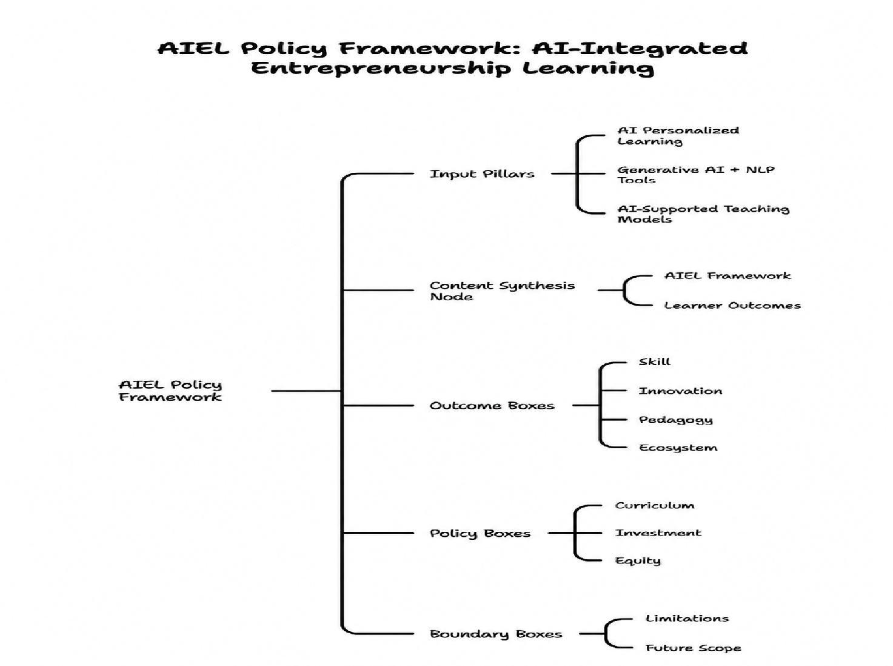
Fig. 4. AIEL Framework: AI-Integrated Entrepreneurship Learning
Existing research has examined adaptive learning mediums such as, LLM assisted learning, virtual incubators, however they are all studied differently. But only a few studies have combined them within a single framework. To address this gap, this study proposes the AI Integrated Entrepreneurship Learning (AIEL) framework, which brings together personalised learning, generative AI supported innovation, and AI enabled support. Unlike studies which were conducted previously focused on individual AI applications or learning models used before the existence of AI, AIEL treats these elements as interconnected. The framework consists of four components. AI literacy should become a core component of entrepreneurship education, universities should invest in AI powered incubators, international organisations should support entrepreneurship enabled by AI education to advance SDGs, and institutions should ensure equitable access to AI technologies to avoid widening educational inequalities.
However, this study is limited by its qualitative approach and reliance on existing literature, which restricts the ability to establish causal relationships. Although the case studies were selected to align with the research questions, they are drawn from an uneven geographical and institutional distribution, with a stronger focus on universities in North America and Western Europe. Furthermore, the rapid growth of AI means that some of the tools and capabilities discussed in the literature may have changed since the original studies were published. Additionally, the increasing use of AI created several opportunities for future entrepreneurs in terms of facilitating better research opportunities. Such studies are needed to compare entrepreneurial outcomes between AI supported and traditional learning environments. The significance of digital platforms is becoming increasingly important in venture creation; therefore, entrepreneurship curricula should adapt their methods in order to adhere to changing business models. To assess the importance of AI supported learning, studies should test the long-term effects of this model in order to check its impact on a student’s critical thinking and academic integrity. Multi-lingual studies were also conducted in order to capture perspectives beyond the English language. Finally, future work should explore AI literacy, vocational education, and issues of equity. Since unequal access to technology may widen educational gaps, cross national studies are needed to provide stronger evidence for policy and practice.
5. Conclusion
This study has explored how AI is ever changing in entrepreneurship education through three key areas, personalised learning, generative AI and innovation supported by NLP, and teaching models which are built with AI. These findings support all three hypotheses, through a qualitative review of literature from Scopus, WoS, ABDC, and IEEE Xplore, supported by industry reports. The evidence from these reports suggests that AI driven personalised learning strengthens the competencies for entrepreneurs, generative AI and NLP tools encourage innovation which are linked to the Sustainable Development Goals (SDGs), and models institutionalized by AI contribute to greater entrepreneurial activity within universities. To address these developments, this study introduces another framework, the AI integrated learning framework (AIEL). Unlike other approaches which consider AI as an additional tool that can be utilised in the classroom, AIEL puts AI as the central component of entrepreneurial education. The AIEL framework combines personalised learning, AI assisted innovation, and institutional support systems to create a more connected and responsive learning environment through the use of AI. These findings also prove to be useful for educational institutions and policymakers. Universities often struggle to prepare students for increasingly technology driven business environments without the incorporation of AI in their academic programmes. However, the unequal access of AI resources could create new barriers of opportunities for entrepreneurs. Therefore, the AIEL framework can be an effective tool as it offers a practical approach for integrating AI into entrepreneurship education while supporting both institutional goals and SDG objectives that could help reduce the gap of unequal access of AI resources.
As AI technologies continue to advance, their influence on entrepreneurship education is likely to increase. Despite the growth of AI technologies, the core purpose of entrepreneurship education still remains the same, to develop individuals who can identify opportunities, manage uncertainty, and create value through innovation. When AI is implemented effectively, it can strengthen this mission by expanding learning opportunities and supporting entrepreneurial development.
REFERENCES
- Zulfiqar, S., Sarwar, B., Huo, C., Zhao, X., & ul Mahasbi, H. (2025). AI-powered education: Driving entrepreneurial spirit among university students. The International Journal of Management Education, 23(2), 101106.
- Vecchiarini, M., & Somia, T. (202x3). Redefining entrepreneurship education in the age of artificial intelligence: An explorative analysis. The International Journal of Management Education, 21(3), 100879.
- Ragolane, M., & Patel, S. (2025). Exploring the Impact of Artificial Intelligence in Entrepreneurship Education: Students' Skills and Capacity to Secure Funding. International Journal of Business and Social Sciencehttps://doi.org/10.30845/IJBSS.V16P10
- Chen, L., Ifenthaler, D., Yau, J. Y. K., & Sun, W. (2024). Artificial intelligence in entrepreneurship education: a scoping review. Education+ Training, 66(6), 589-608.
- Singh, R., Khan, S., Joshi, A., Katragadda, R., & Kumar, V. (2025b). Exploring the role of artificial intelligence on business innovation and entrepreneurship. Strategy and Leadership, 54(3), 302–322. https://doi.org/10.1108/sl-04-2025-0080
- Bell, R., & Bell, H. (2023). Entrepreneurship education in the era of generative artificial intelligence. Entrepreneurship Education, 6(3), 229-244.
- Mu Q., & Zhao Y. (2024). Transforming entrepreneurship education in the age of artificial intelligence. 2024 the Author(S). https://doi.org/10.50908/rdj.3.0_2
- Gong, Y., Wang, S., & Dong, Y. (2025). Integrating artificial intelligence in entrepreneurship education: Dynamic capabilities and marketing performance among student entrepreneurs. The International Journal of Management Education, 23(3), 101248.
- Kimanzi, M. K. (2025). Empowering Future Entrepreneurs Through Artificial Intelligence (AI): With Special Reference to the Role Of AI In Enhancing Entrepreneurship Education. Appraisal of African Development Initiatives. Nairobi: CEDRED, 25, 25-42.
- Dutta, S., Sanwal, T., Sharma, S., Tyagi, M., & Tyagi, S. (2026). AI-powered global value chains: Unlocking efficiency and innovation through education and talent development. In Redefining Innovative Practices In The Age Of AI (pp. 70–76). https://doi.org/10.1201/9781003679295-10
- Al-Omari, H., Zabalawi, I., Malkawi, A. I. H., & Kordahji, H. (2026). Boosting AI Innovation, Technology Transfer, and Industry Collaboration in Arab Higher Education. In Higher Education In The Arab World (pp. 427–466). https://doi.org/10.1007/978-3-031-99068-7_17
- Šmaguc, T., & Kudelić, R. (2024). Natural Language Processing in Entrepreneurship and Small Business Research: An insight, open problems, and implications. In Lecture notes in networks and systems (pp. 682–701). https://doi.org/10.1007/978-3-031-73344-4_60
- Park, T. (2025). The Role of AI Platforms in Enhancing Entrepreneurship Education: A Theoretical analysis. In Lecture notes of the Institute for Computer Sciences, Social Informatics and Telecommunications Engineering (pp. 113–125). https://doi.org/10.1007/978-3-032-06982-5_8
- Thottoli, M. M., Cruz, M. E., & Al Abri, S. S. S. (2025). The incubation revolution: transforming entrepreneurial education with artificial intelligence. Asia Pacific Journal of Innovation and Entrepreneurship, 19(1), 2-23.
- Van Tam, N., Nhat, V. H. Q., & Mai, L. T. T. (2026). Multi-Intelligence University Model: Integrating AI, Entrepreneurship, and Sustainability into Holistic Education. In Advances in Social Science, Education and Humanities Research/Advances in social science, education and humanities research (pp. 459–469).https://doi.org/10.2991/978-2-38476-539-3_31
- Sulistyowati, R., Aripin, J. J., Fikriyah, K., Sobandi, A., Kurniawati, M., Kartiwi, A. P., & Rafliansyah, F. M. Generative AI in Entrepreneurship Education: A Systematic Review of Competency Development, Entrepreneurial Intention, and The Sustainability Disconnect. Entrepreneurship Education: A Systematic Review of Competency Development, Entrepreneurial Intention, and The Sustainability Disconnect.
- Ganuthula, V. R. R. (2025). AI-enabled individual entrepreneurship theory: redefining scale, capability, and sustainability in the digital age. Journal of Innovation and Entrepreneurship, 14(1). https://doi.org/10.1186/s13731-025-00521-9
- Elsa, D., Islami, N., Mahdum, M., Copriady, J., & Putra, Z. H. (2026b). Transforming entrepreneurship education in the age of artificial intelligence: a bibliometric review and future research agenda. Entrepreneurship Education. https://doi.org/10.1007/s41959-026-00174-z
- Fortuna, A., Prasetya, F., Samala, A. D., Rawas, S., Criollo-C, S., Kaya, D., ... & Nabawi, R. A. (2025). Artificial intelligence in personalized learning: A global systematic review of current advancements and shaping future opportunities. Social Sciences & Humanities Open, 12, 102114.
- Katiyar, N., Awasthi, V. K., Pratap, R., Mishra, K., Shukla, N., Singh, R., & Tiwari, M. (2024b). Ai-Driven Personalized Learning Systems: Enhancing Educational Effectiveness. ResearchGate.https://doi.org/10.53555/kuey.v30i5.4961
- Oladele, S., Anector, M., & Foluwa, E. (2025). AI-powered personalization in employee training and development programs authors. Available at SSRN 5226745.
- Lei, H., Liu, Y., & Wei, J. (2025b). How Do Entrepreneurship and AI-Driven Technologies Enhance Organizational Resilience? Evidence from Chinese Enterprises. Sustainability, 17(23), 10494.https://doi.org/10.3390/su172310494
- Awad, A., Abdelaziz, E., Al-Saadi, A., Alnaqbi, J., & Alnaqbi, S. (2024b). Integrating Artificial intelligence in entrepreneurship Education: A study of Higher education institutions in the Middle East. Preprints.org. https://doi.org/10.20944/preprints202408.1140.v1
- Bell, R., & Bell, H. (2023). Entrepreneurship education in the era of generative artificial intelligence. Entrepreneurship Education, 6(3), 229–244. https://doi.org/10.1007/s41959-023-00099-x
- El-Thalji, I. (2025). Boosting active learning through a gamified flipped Classroom: A retrospective case study in higher engineering education. Education Sciences, 15(4), 430. https://doi.org/10.3390/educsci15040430
- Margaretha et al. (2025) his study examined the effect of workplace spirituality and person-organization https://www.eu-jer.com/workplace-spirituality-and-person-organization-fit-pathways-to-faculty-engagement-and-retention
- Menyaoui & Habacha(2025) Data collection timeframes ranged from https://www.ejournal.widyamataram.ac.id.prosiding-uwm.com/index.php/j-mae/article/view/2324
- Alpürk et al. (2025) The convergence of AI, entrepreneurship, and online education https://www.frontiersin.org/journals/education/articles/10.3389/feduc.2025.1651484/full
- Khavasi (2025) This thesis explores the integration of Generative AI (G-AI) into entrepreneurship education at Centria University of Applied Sciences https://www.theseus.fi/handle/10024/882806
- Angelova 2025 The global transformation towards sustainability is challenging https://www.ceeol.com/search/chapter-detail?id=1405941
- Szumska & Weixler (2024) adopt generative artificial intelligence (GAI) for entrepreneurship education https://lup.lub.lu.se/luur/download?func=downloadFile&recordOId=9168309&fileOId=9168322

